An Empirical Study of Artificial Intelligence Patent Litigation
Amy Semet
Associate Professor of Law, University at Buffalo School of Law
Artificial intelligence (AI) is now at the heart of modern innovation, but we know surprisingly little about how AI patents perform when they are challenged in U.S. district courts. This Article offers the first large-scale empirical study that connects the U.S. Patent and Trademark Office’s (USPTO) AI patent database with an originally constructed database of district court outcomes. Using several different methods to identify AI inventions, the study builds tiered measures that classify AI inventions at increasingly levels of confidence. It then examines how these patents fare in court on issues such as invalidity and infringement within the subset of cases decided on the merits.
The results show a clear and consistent pattern. Conditional on reaching a contested merits outcome, AI-related patents are significantly more likely to be invalidated than similar non-AI patents, a result that holds across multiple ways of defining AI as well as numerous control variables. When broken down by legal doctrine, the higher invalidation rate is driven mainly by section 101 subject-matter eligibility. Further, AI inventions are less likely to a statistically significant degree to be found obvious under by section 103. At the same time, AI patents are less likely to yield findings of infringement conditional on a merits-only sample of cases, suggesting they face a double hurdle in litigation: AI patents are easier to invalidate and harder for the patentee to hold an alleged infringer accountable for any infringement.
Crucially, these patterns are not simply the result of AI patents being a substantial subset of software patents. Even when AI software patents are compared directly with non-AI software patents, AI patents remain more likely to be invalidated and less likely to succeed on infringement when examining cases that reach a merits resolution. This indicates that courts appear to be treating AI inventions as a distinct—and particularly vulnerable—category within the broader software space.
These findings carry important implications for innovation policy and patent law. As AI technologies become increasingly central to the economy, the current legal landscape may be systematically disadvantaging a key class of emerging inventions. The Article concludes by exploring possible doctrinal explanations and the need for greater clarity in how patent law is applied to AI-enabled technologies.

Artificial intelligence (AI) appears in a growing share of patented inventions, yet we know little about what happens to those patents once they are litigated. Often described as the next general-purpose technology, with an economic footprint compared to that of the advent of electricity or of the internet, AI has prompted policymakers and industry to call for a coordinated response. The modern patent system was built decades before contemporary machine learning. Structured by the Patent Act of 1952 and revised by the Leahy-Smith America Invents Act of 2011, the legacy patent system did not contemplate how patent law would apply to the unique features that make AI distinctive. Commentators and legislators often assert, without systematic evidence, that AI patents could be uniquely vulnerable under current law due to weak patent quality or overclaiming of the invention itself. Since the Supreme Court’s decision in Alice Corp. v. CLS Bank International, courts and scholars have struggled to say how doctrines designed for earlier technologies should apply to algorithmic and data-centric inventions like software. In particular, concerns surround subject-matter eligibility under 35 U.S.C. § 101. That uncertainty has practical implications. Decisions on whether an invention is even something that is allowed to be patentable now operate as an early and sometimes even dispositive screen, with patents being invalidated under section 101 months into a litigation on motions to dismiss or judgments on the pleadings before the court even has the chance to do claim constructions of the patent itself or to conduct meaningful discovery. Scholars have studied software and business method patents post-Alice at length, and others have examined patent quality and outcomes at the PTAB and in the district courts. But examining how AI patents, as distinct from software patents, fare against non-AI patents across several doctrinal grounds is a notable gap in the empirical scholarship. Indeed, much of the technical literature uses machine learning to actually study patents rather than studying AI patents themselves.
In part, we know remarkably little about AI patents empirically because there is no agreed definition of what counts as an AI invention. This Article takes up that question with a large-scale study of AI patent litigation in the federal district courts. The Article makes two key contributions. The first is definitional. Starting from the USPTO Artificial Intelligence Patent Dataset, I operationalize several definitions of an AI patent, from a baseline threshold to two higher-confidence thresholds. The second contribution is empirical. From over 80,000 district court decisions filed between 2000 and 2025, I identify which involve an AI patent, trace how AI patents have been litigated over that period and compare outcomes for AI and non-AI patents across the doctrines that decide most cases: section 101 eligibility, the prior-art screens of sections 102 and 103, and the disclosure requirements of section 112, as well as infringement under section 271.
Conditional on reaching a contested merits outcome, I find that AI patents are significantly more likely to be invalidated in the district courts and, at the same time, significantly less likely to be found infringed than otherwise comparable non-AI patents. The asymmetry survives multiple AI definitions and probability thresholds of what constitutes an “AI invention.” The findings are also robust to a broad set of case- and patent-level controls. Disaggregated by doctrine, the elevated invalidation rate traces largely to subject matter invalidations under section 101. AI patents remain more likely to be invalidated under section 101 even after accounting for the general post-Alice increase in eligibility invalidations. In addition, AI patents are less likely to be found obvious under section 103, a result some may find unexpected.
These results cannot simply be explained by the fact that AI inventions often overlap with software inventions. When I restrict the sample to just software patents, AI patents retain a statistically significant association with higher invalidation risk, especially on section 101. This association on invalidity persists if I look at the results using a non-software sample as well. The reverse is true for infringement; while the AI indicator is not statistically significant in the software-only sample, it is statistically significant in the non-software sample, indicating that the AI discrepancy with respect to infringement is largely limited to non-software inventions. In most specifications, it is still easier for parties accused of infringing an AI patent, especially a non-software-based AI patent, to escape liability on infringement than it would be for them to survive an infringement allegation on a comparable non-AI patent.
The stakes are real. Commentators and legislators worry that the post-Alice section 101 framework either over-deters valuable innovation or fails to restrain overbroad functional claims. Congress has repeatedly considered, though never enacted, proposals to reform eligibility. Courts meanwhile continue to police patent scope through sections 102, 103, and 112. Knowing where, doctrinally, AI patents actually run into trouble is a precondition to deciding whether further judicial or legislative intervention is warranted.
The Article proceeds in five Parts. Part I sets out only the doctrinal and institutional background needed to read the results, then explains why AI inventions might behave differently in litigation. Part II describes the data and the definition of an AI patent, including the graded measure I use throughout. Part III reports the descriptive patterns. Part IV presents the multivariate models and the robustness checks, including the within-software comparison and the breakdown by statutory ground. It also examines results pre and post-Alice, making clear that the sharp difference in invalidity outcomes is largely a post-Alice phenomenon. Part V develops the doctrinal and policy implications and sets out where courts, the USPTO, and Congress might respond. By grounding the debate in systematic evidence rather than anecdote, the Article offers a first map of where the patent system’s capacity to sort genuine advances from overbroad functional claims is under strain.
I. Doctrinal and Institutional Foundations
A. Patentability and Forums
Patent litigation runs through a series of statutory filters that decide which inventions merit protection. Four provisions of the Patent Act, 35 U.S.C. §§ 101, 102, 103, and 112, do most of the work in modern validity disputes. While formally technology neutral, each has become especially consequential in litigation over software and AI.
Section 101 sets the categories of patentable subject matter. The statute reaches “any new and useful process, machine, manufacture, or composition of matter,” capacious language the Supreme Court has nonetheless read to create judicially-created exceptions to specifically exclude laws of nature, natural phenomena, and abstract ideas. Eligibility today is governed by the two-step framework of Alice Corp. v. CLS Bank International: a court first asks whether the claims are directed to an ineligible concept, most often an abstract idea, and if so, the court must then ask whether the remaining elements supply an inventive concept sufficient to transform the idea into a patent-eligible application. Alice itself claimed a computerized method for intermediated settlement. The Court held it ineligible because it did no more than simply “apply” a longstanding economic practice to run on a generic computer. Lower courts have extended that reasoning to software and data-processing claims that recite a functional result, such as analyzing data with a model without specifying any concrete technological improvement. So many AI and software inventions turn on algorithmic processing or data manipulation, the very features courts are prone to call abstract, that section 101 has acquired outsized importance. A large literature documents both the instability of Alice and its uneven effect on digital technologies.
Anticipation or novelty inquiries under sections 102 and obviousness analysis under section 103 police whether the invention is preempted by the prior art. Section 102 denies a patent to an invention that the public already had access to in full before the applicant’s filing date. The inquiry is reference-based and binary, so a single prior-art reference disclosing every claim element anticipates the claim. Section 103 bars a patent where the claimed advance would have been “obvious” to a person of ordinary skill, weighing the scope of the prior art, the differences from the claim, the level of skill, and objective indicia. In AI cases obviousness usually reduces to a single question: whether combining known machine-learning techniques would have been routine or instead reflects a genuine inventive step. Section 112 turns to disclosure. The specification must describe the invention, enable a skilled artisan to make and use it, and define the claims with reasonable clarity. These are three separate distinct requirements: the patent must be enabled, it must satisfy the written description requirement, and it must not be indefinite. Failure to satisfy any of those requirements by itself is sufficient to invalidate the claim of the patent. Those requirements matter increasingly where a patent states a result at a high level of functional abstraction while leaving the implementation unspecified.
These doctrines are tested in several forums, with the district courts being the primary venue and the focus here. Most cases in the district court concern infringement, whereby a patentee can sue an alleged infringer for making, using, selling, offering to sell or importing the claimed invention in violation of the patentee’s property right. Alleged infringers can also be liable for indirect infringement if they induce or contribute to direct infringement of another party. If found liable, infringers may have to pay money damages and could be enjoined from practicing the claimed invention. Two specialized forums sit alongside the courts, with more limited scope on what can be reviewed. The Patent Trial and Appeal Board (“PTAB”) hears post-grant proceedings, most prominently inter partes review, in a faster and usually cheaper forum confined largely to novelty and obviousness based primarily on paper prior art only. It does not hear infringement cases; it only adjudicates limited validity disputes. As such, the PTAB adjudicates few § 101 cases. The International Trade Commission (“ITC”) hears disputes over imported goods under Section 337 of the Tariff Act, where the principal remedy is an exclusion order at the border rather than damages. Across these forums, § 101 frequently decides whether a software- or data-driven invention survives early motions, §§ 102 and 103 test the technological advance, and § 112 increasingly asks whether the patentee disclosed how the AI system actually works.
B. Why AI Inventions May Differ
AI inventions have rapidly increased in growth the past few years. Stanford University’s AI Index reports that the number of AI patents granted globally rose from 3,833 in 2010 to 122,511 in 2023, with China holding nearly 70% of granted AI patents in 2023 against about 14% for the United States, even as the United States retained a clear lead in patent citation impact. That growth matters because the closest doctrinal analogue to AI—the software patent—has a cautionary litigation history. Software and business-method patents have long shown to have a higher invalidation risk and more volatile outcomes than other technologies, with little evidence that the patenting surge tracked research intensity. To the degree AI patents resemble software patents in form and function, they could inherit that vulnerability.
While the Patent Act is technology neutral on its face, that does not necessarily mean that it operates neutrally in practice. AI patents may differ from non-AI patents in how the patented features of the invention are written up in the claims. Claims are the operative sentences at the end of a patent that fix the boundaries of the inventor’s exclusive rights; courts liken them to the metes and bounds of real property. A traditional claim for a mechanical invention may recite a concrete structure such as a gear or fastener. AI claims are often worded differently. They typically lean on functional language, describing what a system does rather than the structure that does it. For example, a claim might recite a system “configured to classify images using a trained model” without specifying the model’s architecture or how it was trained. Functional claiming is not new. Courts have been more hesitant to uphold patent claims with functional language, fearing that it lets a patentee capture broad territory without teaching others how to build the invention.
These drafting features of an AI invention, however, pose potential problems with satisfying statutory requirements for sustaining validity. The disclosure requirements of section 112 ask whether the specification of the patent teaches a skilled reader to “make and use” the full scope of what is claimed. AI inventions strain that disclosure demand precisely because their key performance characteristics depend on training data and optimization that the patent might not disclose. Many AI systems may be defined by data, training method, or performance rather than by any fixed architecture, so their claims sit close to the line between permissible functional description and impermissible abstraction. The Supreme Court’s revival of enablement scrutiny for result-defined claims bears directly on AI patents that recite a desired output while leaving the technical means unspecified. Compounding the problem, much of an AI system’s genuine know-how such as training data is kept as a trade secret rather than committed to the public record, widening the gap between what is claimed and what is disclosed, creating potential obstacles to sustaining the patent’s validity. The same features expose AI claims under section 101. Inventions that turn on algorithmic processing, mathematical models, or data manipulation read to many courts as abstract results implemented on a generic computer—the very profile of an invention that drew invalidation after Alice. The Patent Office has acknowledged the difficulty, issuing guidance in 2024 directed specifically at the eligibility of AI-assisted inventions. The boundary problem extends even to who may hold the patent: the Federal Circuit has held that an AI system cannot be named an inventor, marking one more doctrinal seam that AI presses against.
Novelty and obviousness under sections 102 and 103 cut in a subtler direction for AI inventions. AI research advances quickly and builds openly on published algorithms and shared architectures, which may enlarge the pool of relevant prior art and make a claimed advance look like a routine combination of known techniques. The level of ordinary skill is itself moving, because AI is both the invention under examination and a tool that ordinary practitioners increasingly use, so what once required invention may now be obvious to try. At the same time, many AI inventions involve specialized implementations that genuinely distinguish them from what came before.
AI inventions are not also monolithic. Patents on hardware acceleration or robotics carry substantial structural detail and resemble traditional engineering patents while patents on data processing and predictive modeling resemble the business-method and software patents that Alice hit hardest. That split poses an empirical question this Article takes up directly: whether any AI disadvantage runs across the whole category or concentrates in particular subfields. For all the theoretical attention these features have drawn, large-scale evidence on how AI patents actually fare in litigation is scarce. The prior work thus yields a clear but incomplete expectation. Because AI patents share functional claiming and algorithmic subject matter with software patents, they should draw elevated scrutiny under current doctrine. Yet AI’s diversity, and its growing structural embodiment in hardware and robotics, could soften that effect in some subfields. Which tendency dominates is an empirical matter, and it is the question I take up next.
II. Data, Definitions, and Design
A. The District Court Dataset
I built the litigation data from the ground up, beginning with cases filed in 2000. I started with the Federal Judicial Center’s Integrated Data Base, drawing nature-of-suit codes 830 and 835 from PACER. I then confirmed and supplemented those codings from other sources. I reviewed each case independently to fix its operative disposition, and where my reading diverged from a secondary source, I coded from the underlying documents. Patent litigation clusters around repeat filers and campaign-style enforcement, especially in high-volume venues, so many filings are duplicative. Where they involved different patents or diverged procedurally, I examined them individually in detail. The most labor-intensive were cases of mixed disposition, for example, cases in which one patent fell on summary judgment while others went to trial or where some claims were disposed of by pre-trial motions, while others were decided at trial.
The full database contains much supplementary information on each patent and case. I added party characteristics from the Stanford NPE Litigation Database and other sources, classifying plaintiffs by entity type to identify patentees that were “non-practicing entities.” Patent-level characteristics came from USPTO’s PatentsView data: issuance date, number of claims, assignee nationality, backward and forward citation counts, and other information discussed later in the Article.
The coding of the case goes deeper than just coding for the disposition. For each case I recorded whether the matter was a declaratory-judgment action, whether it was appealed, and the outcome of major motions, with jury and bench dispositions kept separate. I coded the substantive patent issues primarily from the documents and cross-checked them against other classifications, capturing infringement, anticipation, obviousness, subject matter, written description, enablement, best mode, definiteness, derivation, correction of inventorship, double patenting, and inequitable conduct, among others. As a robustness check, I downloaded most written opinions, judgments and other documents from both the district court and the Federal Circuit. I then uploaded them to both Claude and Codex to create competing summaries of these documents to cross-check my own coding of the key information and dispositions. I also flagged the cases in which claim construction was effectively the only disputed issue. Remedies including injunctive relief and damages were recorded as applicable.
B. Defining an AI Patent
With the corpus in hand, I had to decide whether each case involved an AI patent. That is harder than it sounds, because there is no accepted definition of an AI invention, as the Organization for Economics Co-Cooperation and Development (OECD) recently noted in its report on AI. Further, the definition of what constitutes an AI invention is itself a moving target. The OECD revised its definition of an AI system in 2024, and the USPTO has continued to refine how it identifies AI, both through examination guidance directed at AI eligibility and through updates that extend the dataset I use here to more recently issued patents. Because the boundary of the category keeps shifting, a measure that fixed AI to one definition would inherit whatever choices the latest revision happened to make. We are continuing to learn more and better ways of defining what constitutes an “AI invention.”
To deal with that concern, I code for an AI invention in several different ways. I rely principally on the USPTO Artificial Intelligence Patent Dataset, which applied a machine-learning framework to identify AI-related inventions across U.S. patents issued between 1976 and 2023. The USPTO trained its classifier on textual features drawn from abstracts and claims together with backward and forward citation information, using a seed set of confirmed AI documents and an anti-seed of negative examples to supervise learning over the broader corpus. It then checked the model against a sample of classifications made by examiners with AI expertise. The methodology builds on the automated-landscaping approach but extends it with claim-level analysis to capture the technical and legal scope of the invention more precisely. The USPTO also updated its model in 2023 to capture more AI patents. That the model relies on claim and citation features rather than keywords alone is part of why it generalizes across fields. It is also why a competing keyword- or class-based database like that of the OECD can disagree with it so sharply.
The USPTO database then assigns each patent a probability between 0 and 1 and it flags an invention as AI at a probability of at least 50%. Because the data give probabilistic scores rather than hard labels, I use the 50% cutoff for the main specification. However, since the default 50% threshold is built for coverage and sweeps in borderline cases near the decision boundary, I add two stricter definitions based on the thresholds the USPTO used itself: one at 86%, a high-confidence region in the model’s validation, and one at 93%, capturing patents the model identifies as AI with near certainty. The strict thresholds shrink the treated group but offer a demanding test against classification noise. The tiered, multi-threshold approach I use lets the findings be read against several defensible definitions rather than betting the analysis on one.
The three-tiered classification scheme behaves as one would hope across these cutoffs. At the 50% cutoff, the dataset contains 1.3 million patents across time; at the 93% cutoff, it contains around 860,000. That is a contraction of 34.9% which is substantial but not unexpected. Importantly, as shown in in Figure 1, AI prevalence falls monotonically across the thresholds. That lets me feel confident that the three thresholds are in fact progressively stricter definitions of AI intensity rather than different definitions of an AI invention. As seen in Figure 1, the time trend is consistent with that interpretation. Between 2014 and 2023, AI patents at the 50% threshold increased 45%, while at the 93% threshold, the increase was at 62%. The stricter definition therefore grows at least as quickly as the broader one. The result suggests not simply that more patents are being loosely tagged as AI over time, but that the stock of patents carrying strong AI signals is expanding as well. What narrows as one moves from the 50% to 93% thresholds is not the growth trajectory, but the breadth of the AI category.
Figure 1: Annual USPTO Annual AI Patents by Threshold
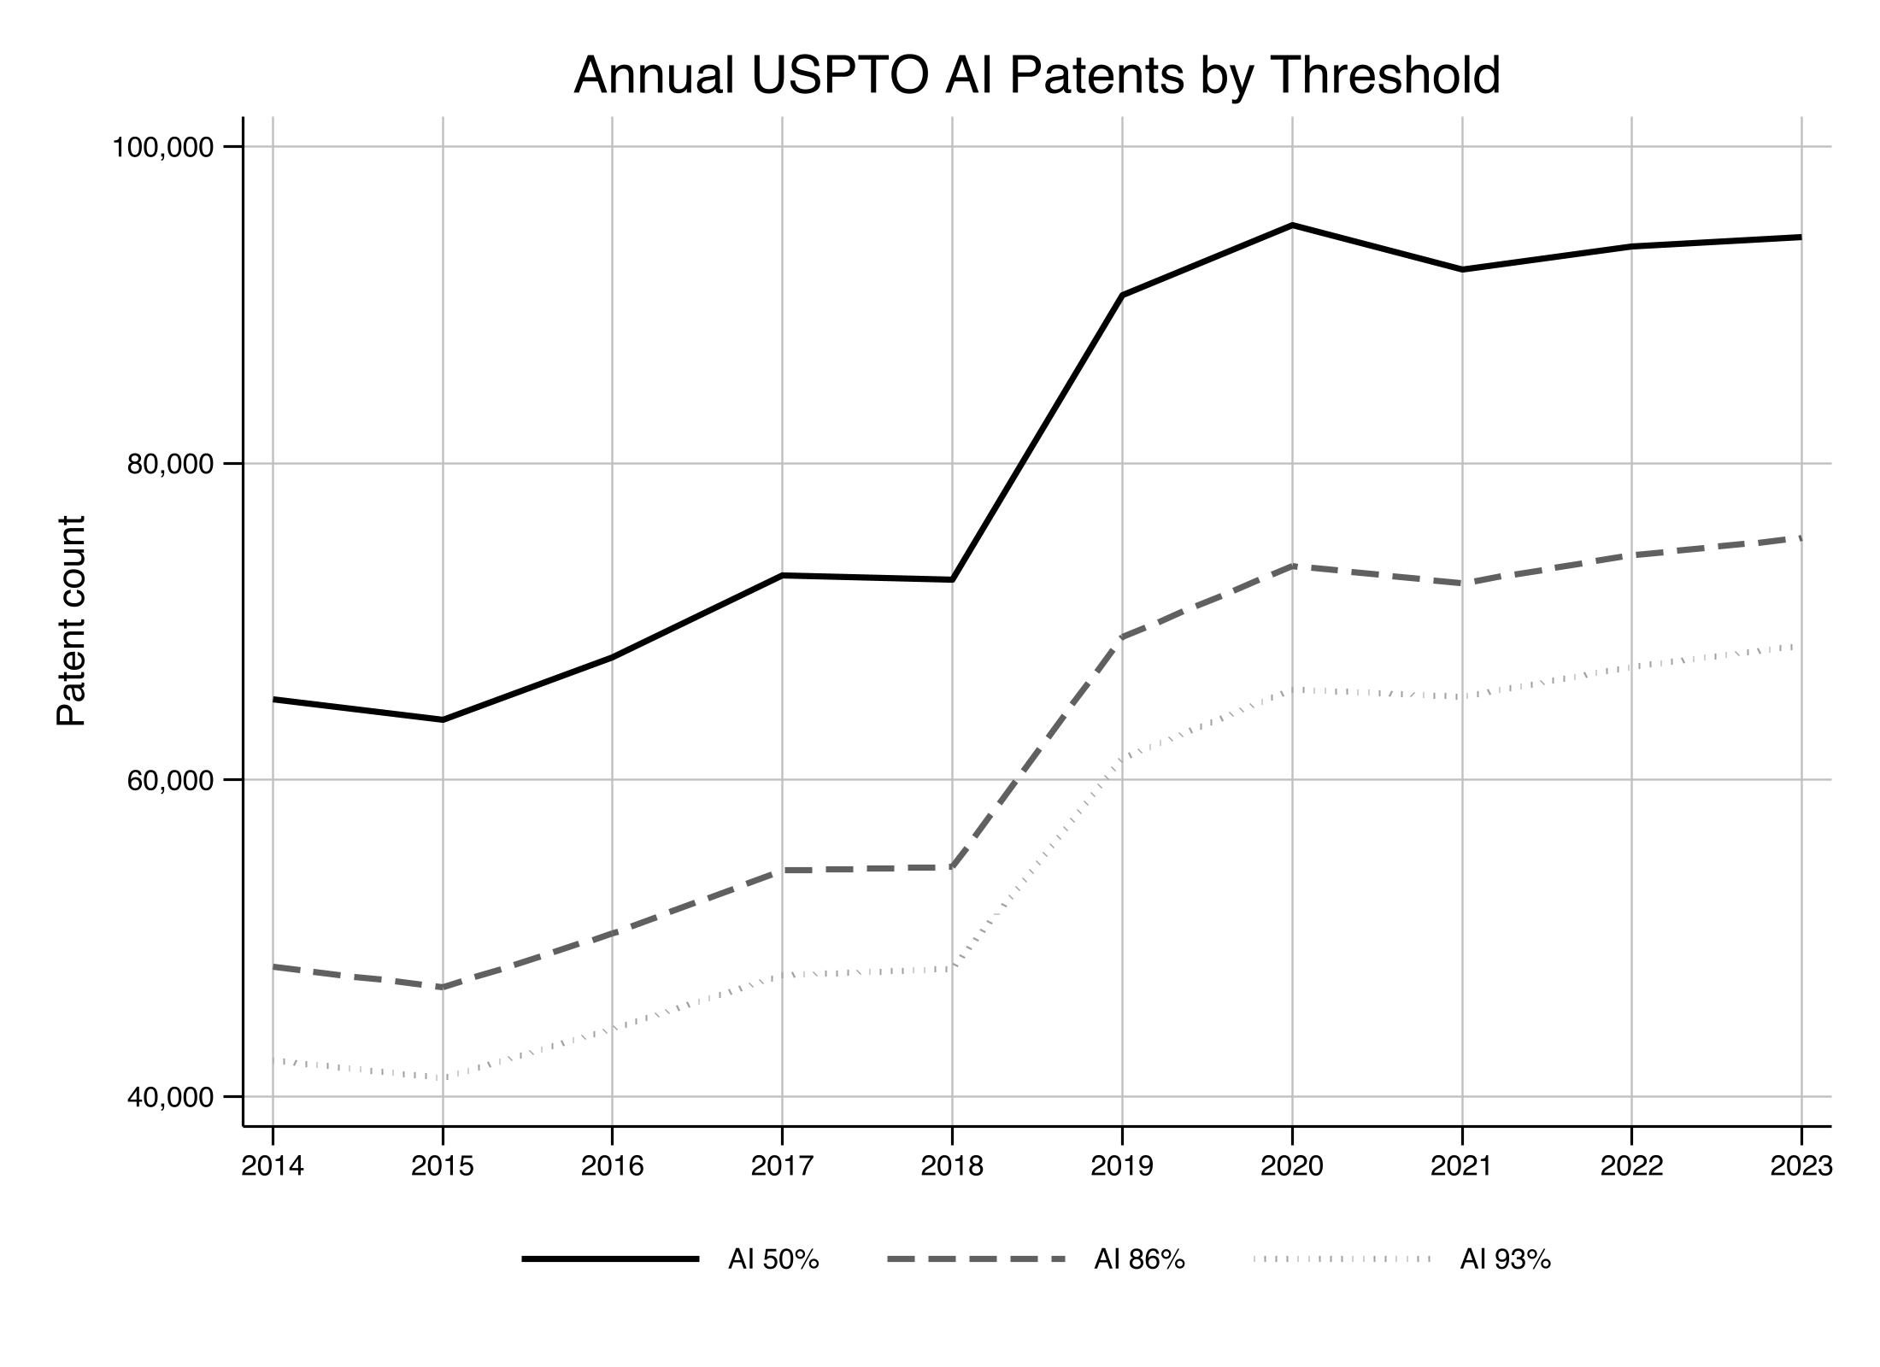
The subject-matter mix also remains recognizably stable across the three thresholds, though it is not wholly unchanged. The USPTO divides AI inventions into eight potentially overlapping components: knowledge processing, speech, hardware, evolutionary computation, natural language processing, machine learning, vision, and planning and control. Figure 2 shows the technological categories common among AI inventions, as defined by the USPTO database across the three thresholds. Across the full corpus the largest categories are hardware and planning and control patents.. As the confidence threshold increases, the number of patents classified as AI declines substantially—from approximately 1.24 million patents at the 50% threshold to approximately 650,000 at the 93% threshold—reflecting the exclusion of patents with less certain AI content. At the same time, the technological composition of the dataset remains remarkably stable. Hardware is consistently the largest subfield, followed by planning and computer vision, while natural language processing, machine learning, evolutionary computation, and speech remain smaller but persistent components of the AI landscape. Because the USPTO subfields are non-exclusive, patents may appear in multiple categories, so the subfield counts should not be interpreted as shares of the overall AI universe. Nonetheless, the largely unchanged ordering of subfields across thresholds suggests that increasing the confidence threshold primarily removes marginal AI patents rather than materially altering the technological makeup of the dataset. This stability provides reassurance that empirical results are unlikely to depend on the particular confidence threshold used to identify AI patents.

Figure 2: USPTO AI Database by Subfield and Confidence Threshold
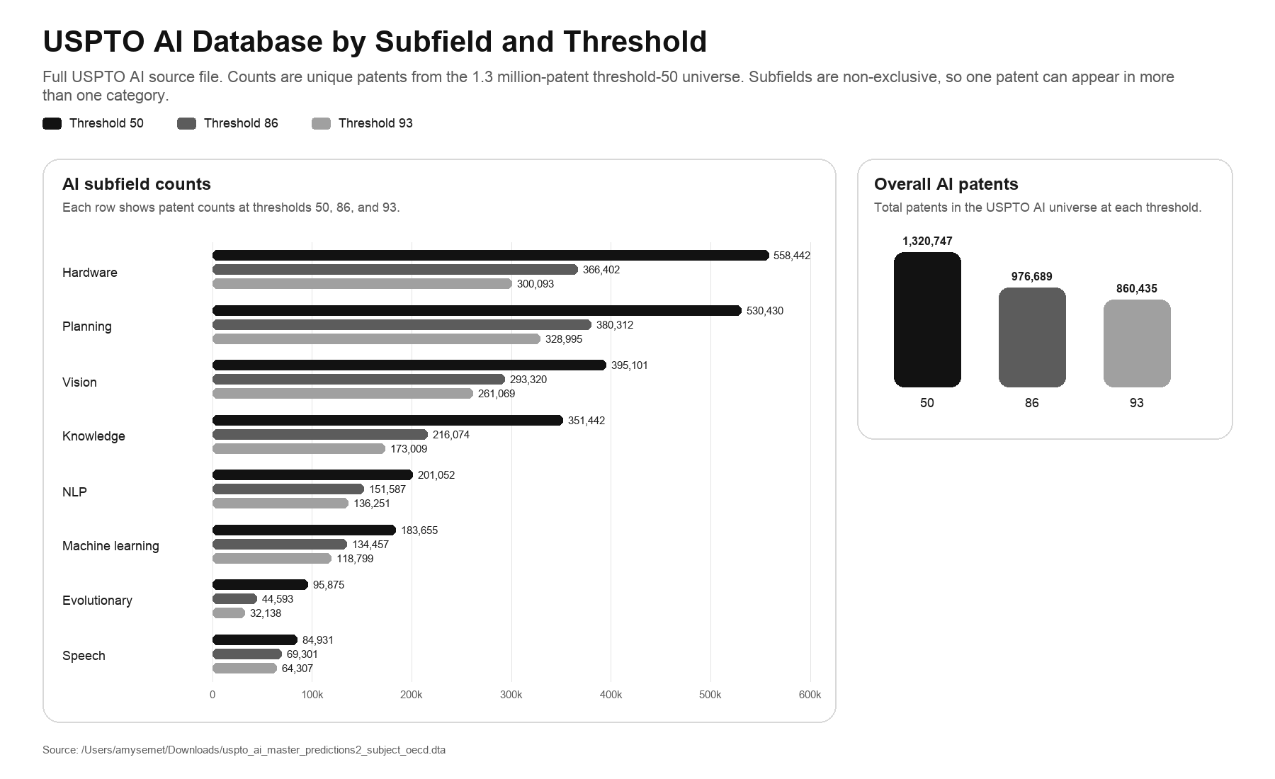
III. Descriptive Results
A. Litigated AI Patents
I now restrict attention to the almost 80,000 patents litigated in the district courts. Between 2000 and 2025, almost 14,000 litigated patents involved AI technology. In all, about 15% of patents litigated over the past twenty-five years involved AI, as classified by the 50% threshold of the USPTO AI Database. Further, almost a third of district court cases involved at least one patent classified by my taxonomy as an AI invention. Figure 3 shows the AI subfields. The litigated mix tracks the AI patent population generally, with planning, hardware, and knowledge patents representing the largest shares. Among the subfields, planning patents are the largest litigated AI subfield at 45%, followed by hardware patents at 33% and knowledge representation patents at 28%. Those shares are non-exclusive, so they do not divide the AI universe into clean buckets, but they do show that the litigated set is not just a machine-learning docket in disguise. It is a broader software-and-systems docket in which planning, hardware, and knowledge-oriented technologies still do much of the work. Even as the confidence threshold increases, the general pattern of the technological mix remains the same.
Figure 3: Litigated AI Patents, by Subfield, Confidence Threshold and Year
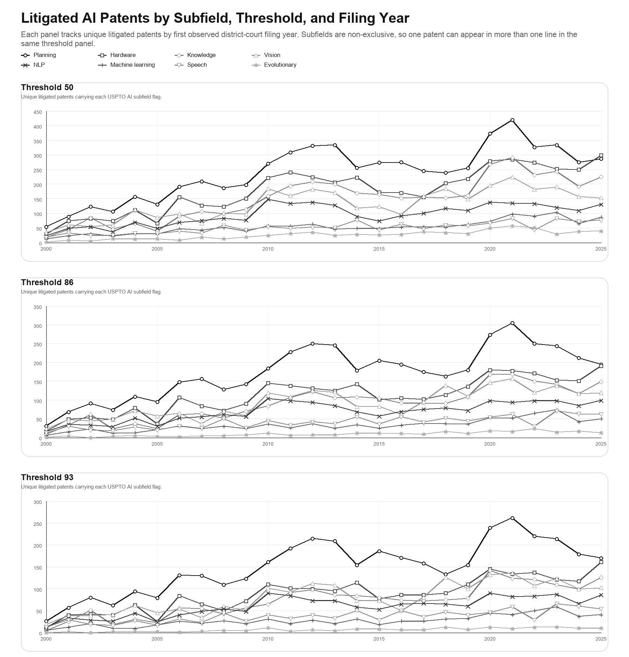
Nonetheless, software patents constitute a sizeable share of AI inventions. I separately classified technological type using CPC definitions. By technological field, the AI signal is anchored in the computing ecosystem. Over 40% of AI patents fall in software and computing, compared with only 6% of non-AI patents. Telecom / networking patents are the second-largest AI category at 25%. The life-sciences footprint is comparatively small, with biology and chemistry showing visible but modest AI shares.
Figure 4 shows the number of litigations of AI patent per year. The filing-year figure should be read as a case-volume figure rather than as a distinct-patent figure. On the patent-case measure, AI litigation surges early and remains high. But the distinct-patent line tells a different story. Unique AI patents litigated by filing year rise over time. Relative to non-AI litigated patents, litigated AI patents occupy a much larger share of litigation over time, even though overall patent litigation has been fairly flat, especially post-2011. This result is unsurprising given the growth of AI. The widening gap over time suggests that the early increase may have been driven disproportionately by repeated litigation involving a relatively small set of AI patents, whereas the later increase appears to reflect growth in the number of distinct AI patents entering litigation.
Figure 4: Litigated AI Patents Compared to All Litigated Patents
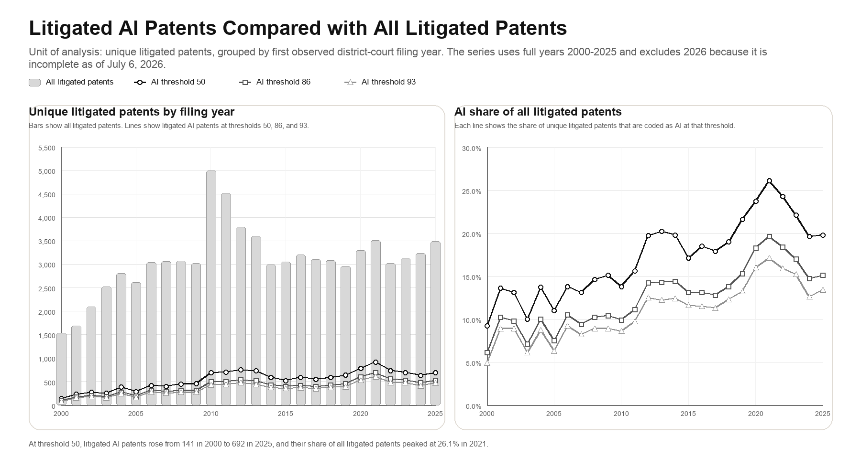
The venue and party structure results show that this is not just the ordinary patent docket with a relabeled technology field. The Eastern District of Texas alone accounts almost a third of AI patent cases, compared with less than a fifth of patent cases overall. Delaware and the Western District of Texas also loom large, as they do in patent litigation generally. But the effect is even more attenuated for AI patents. For example, about 22.6% of AI patents are litigated in Delaware compared to 16.3% overall. What the concentration means institutionally is that a small set of judges, in a handful of districts, write much of the district court law on AI patents. Thus, the development of that law will reflect the docket pressures and local practices of those particular courts rather than a representative cross-section of the federal bench.
Litigated AI patents also differ in other ways from non-AI litigated patents. AI patents average 27.4 claims versus 19.6 mean for non-AI patents, 103.2 forward citations versus 60.7 mean for non-AI, and 95.4 backward citations versus 74.2 mean for non-AI. Forward citations are a rough indicator of how often later patents build on or cite a patent, while backward citations capture how densely the patent is tied to earlier prior art. On both dimensions the AI set looks more connected and more crowded than the non-AI set, which is what one would expect if litigated AI patents tend to sit inside fast-moving software and platform ecosystems rather than in isolated technological niches. The patents are also modestly older when first litigated, at 5.8 years from issue to first case versus 5.3.
Litigated AI patents also look more dominated by non-practicing entities—often labeled “patent trolls”—as plaintiffs. Across all litigated patents, most plaintiffs are large operating companies such as Kodak or General Motors or Samsung Electronics. For AI patents, the single largest group of plaintiffs are firms that acquired the patent from another company. That is unsurprising. A company that wants AI technology often buys the firm that holds it, then turns the acquired portfolio against competitors. Individual-inventor startups also make up a disproportionate share of AI plaintiffs, while operating companies and individuals appear somewhat less often than in non-AI cases. The pattern looks much the same for declaratory-judgment defendants. On the plaintiff side, acquired or NPE-type entities account for almost half of AI litigated cases but only a little more than a quarter of non-AI cases, while operating companies account for about a fifth of AI cases compared with half on the non-AI side. The data thus indicate that there is an active secondary market in AI patent litigation rather than a wave of original-inventor enforcement.
Litigated AI patents are also more domestic in origin and more exposed to repeat challenges in court and in administrative agencies than the broader non-AI patent docket. More than a quarter of AI patent litigations are filed by parties based outside the United States. The United Kingdom and Canada lead, together supplying nearly a third of all foreign AI litigated patents, and India and Korea are overrepresented relative to their overall patent totals, each contributing about 10%. AI patents are less likely to have a foreign assignee (14.1% versus 20.9%) and less likely to carry the foreign-plaintiff or foreign-defendant tags (3% versus 4% for plaintiffs, and 4% versus 6% for defendants). AI patents are asserted in 4.6 district-court actions on average, compared with 3.0 for non-AI patents, and they are attacked at PTAB far more often, at 23.6% versus 11.9%. By contrast, ITC involvement is relatively flat between AI and non-AI litigated patents (about 2%).
AI patents are also more likely to be disposed of early in the case through motions to dismiss or judgment on the pleadings. The procedural story is easiest to see in the full patent-case file, because that is where the settlement-heavy mass of ordinary case endings is preserved. Pleadings account for 2.4% of all AI patent-case rows compared with 1.9% for non-AI rows, whereas non-AI patents are more likely to reach summary judgment (2.0% versus 1.5%), trial (2.4% versus 1.6%), and JMOL (0.3% versus 0.1%). Limited to only cases where the court reaches a merits decision, the discrepancy is even more stark: AI patents in which a merits result is reached end in judgment on the pleadings 30.3.0% of the time, compared with only 7.4% for non-AI patents, a result statistically significant at 99% confidence. For invalidity determinations, AI patents are disposed of on the pleadings in 37.1% of the time compared to just 9.5% for non-AI patents. The procedural account is therefore not that AI disputes are uniquely trial-intensive. It is closer to the opposite: when they do not settle they are more likely to be screened out early. The pattern holds across all eight technology categories, which marks it as a structural feature of AI cases rather than a quirk of a few fields.
The heavy use of judgment on the pleadings makes sense once one looks at the grounds on which AI patents are invalidated. After Alice, § 101 has become a potent screen in software-adjacent fields. The modern “plausibility” regime established by the Supreme Court in Twombly regime asks a plaintiff to plead infringement with factual specificity. Where conventional cases can satisfy that bar by describing an accused device’s observable features, AI systems are frequently opaque, distributed, or dependent on proprietary models that resist inspection before discovery. This makes it easier for an accused infringer to prevail on a judgment on the pleadings, or even a summary judgment motion. Section 101 and heightened pleading scrutiny thus combine into an early-stage filtration that is unusually strong in AI litigation.
B. Validity and Infringement Outcomes
Conditional on reaching a merits outcome, which is the case sample that this Article focuses on, non-AI patents are significantly less likely to be invalidated than AI patents, with the differences in the cross-tabulations statistically significant at the 99% confidence level. The size of the gap varies by technological field even though its direction does not, with the difference most stark not surprisingly in software-proximate domains. Figure 6 breaks down the invalidity results by statutory section. Compared with non-AI, AI patent-case rulings are far more likely to end in overall invalidity (74.2% versus 47.9%), especially in final section 101 invalidation (64.3% versus 25.2%). For all other statutory subsections, AI inventions run behind non-AI inventions. Definiteness is higher among non-AI inventions (25.8% v. 18.6%). The non-AI sample also runs higher on section 102 (24.2% versus 11.3%) and section 103 (24.3% versus 6.2%), so the doctrinal separation is mainly an eligibility story rather than a prior-art story. Invalidations based on written description (6.7% for non-AI versus 3.3% for AI) and enablement (4.2% for non-AI versus 2.8% for AI) reveal a similar pattern. The obviousness result is the one most worth dwelling on, because it cuts against a natural assumption. One might expect AI and software patents, often criticized as combining known techniques, to fall disproportionately on section 103. But they do the reverse. Both AI software and traditional software are significantly less likely than the baseline to be invalidated for obviousness, which means the prior-art doctrine that is doctrinally best suited to police routine recombination is doing comparatively little of the invalidating in this space. Read alongside the section 101 result, the pattern describes a system that has substituted a threshold characterization, is this an abstract idea, for the fact-intensive comparison the prior-art doctrines were built to perform. That substitution is efficient in the narrow sense that it resolves cases early and cheaply. It is inefficient in the sense that matters for innovation, because it sorts patents on a legal label rather than on the technical question of whether the claimed advance was actually new and nonobvious, and the data give no reason to think the label and the technical merit line up closely for AI. Invalidation is highest for machine learning (87.6%), knowledge representation (83.9%) and planning (82.5%) patents. It is much lower for evolutionary computation (67.5%) patents in particular, though it is still above the non-AI baseline.
Figure 6: Invalidity Outcomes: AI Confidence Tier 50% versus non-AI
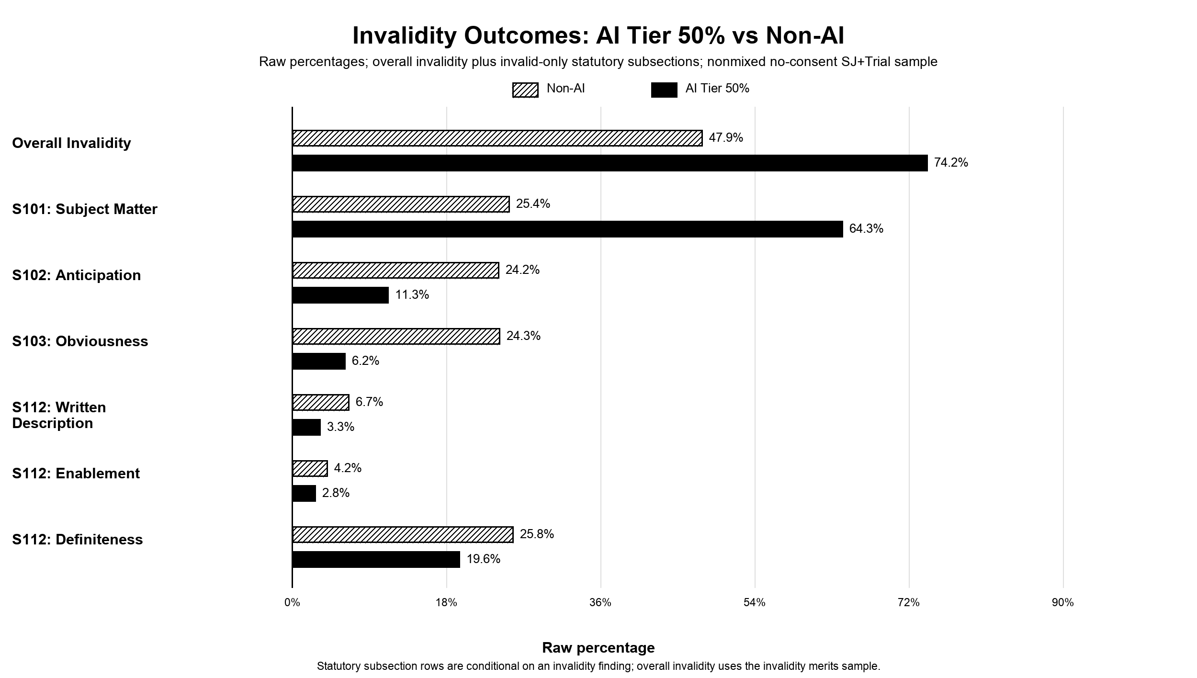
The liability evidence on infringement is weaker in magnitude and more heterogeneous than the validity evidence. But the differences between AI and non-AI patents are still statistically significant. Validity doctrines apply to the patent as written and should respond fairly uniformly to abstraction and prior-art density, so a penalty rooted in eligibility should travel across subclasses. Infringement in turn turns on the architecture of the accused system and the specificity of the claims, which naturally introduces subclass variation, so a penalty rooted in proof difficulty should vary with how observable the technology is. AI patents are found infringed in 24.0% of observations, compared with 34.7% for non-AI. Infringement findings are especially lower in NLP (19.0%), machine learning (21.0%), vision (21.3%) and knowledge representation (20.4%), where “no infringement” rulings are more common. The technology makes this unsurprising. NLP-based AI systems rely on training data and keep changing as they process new inputs, so infringing uses can be hard to observe and may occur only momentarily. The infringer can also be hard to identify as well, because AI is often developed by one entity, sold to a second, and trained and operated by a third, so pinning the direct infringer of a method claim when several actors each perform a distinct step becomes difficult. Jurisdiction adds a further layer, since a neural network distributed across the cloud in several countries may have no fixed place of infringement. Infringers can be direct or indirect, and as such, it may be especially hard to prove indirect infringement of an AI patent, especially by third parties. Whether an AI program has substantial noninfringing uses, and so escapes contributory liability, can be difficult to determine. Inducement is harder still, because the knowledge it requires is elusive. Consider a party that supplies a training set to another that uses it to infringe and ask whether the supplier induced the infringement. These questions are specific to AI, and the law may have to adapt to answer them. AI systems may also be spread among third parties, and accused systems in these fields may be harder to map onto the claimed elements, whether from narrower effective scope or greater architectural complexity.
IV. Multivariate Results and Robustness
The descriptive patterns suggest that AI patents face distinct procedural and doctrinal headwinds on both invalidity and infringement. Cross-tabulations cannot tell me whether those differences come from AI status itself or from correlated case characteristics such as technology mix, forum, party type, claim scope, or litigation posture, each of which also affects case outcome. Multivariate regression isolates the marginal effect of AI classification while holding other observable features constant. I estimate linear probability models in which each patent-case outcome equals one it is represents an AI patent and 0 otherwise. The main specification uses the 50% confidence threshold to define an AI invention, with the 86% and 93% thresholds added as robustness checks in some specifications.
To isolate the relationship between AI status and outcomes, I first include an extensive set of patent-level controls. Patent age is the number of years between issuance and the filing of the litigation or the date on which the court makes the validity and/or infringement determination. I also include the logged number of claims of the patent, which capture scope and drafting density. Claim count also proxies for breadth, because a patent with more claims is mechanically more likely to have at least one claim invalidated. I include logged backward and forward citation counts. Backward citations proxy for prior-art density and exposure to §§ 102 and 103, and forward citations track technological impact and litigation salience. The empirical literature has long treated patent citations as informative proxies for innovation impact and knowledge spillovers. Party controls include whether the asserter is a non-practicing entity. Because patent disputes increasingly run across forums, a parallel indicator equals one when the asserted patent is also challenged at the PTAB or the ITC during the life of the case. These cross-forum measures capture both a selection effect, in which weaker patents draw more challenges, and the shadow that one forum casts on another. I also downloaded patent-specific files from PatentsView and classified whether the assignment and/or the inventor of the patent came from a foreign country. In addition, I included in various models fixed effects that absorb what the covariates cannot. District, technological and year effects hold constant the venue, technological field and doctrinal era. I estimate linear probability models at the patent-case level with standard errors clustered at the patent, which keeps interpretation transparent and accommodates the high-dimensional fixed effects common in patent litigation analysis. The results are robust to alternative definitions of the unit of analysis such as if the data are collapsed to unique case-court units or to unique patents. Table 1 reports summary statistics.

Table 1: Summary Statistics for Regression Variables
Variable | Sample | N | Mean | SD | Min | Max
AI Tier 50% | Invalidity merits | 5,751 | 0.297 | 0.457 | 0.000 | 1.000
AI Tier 86% | Invalidity merits | 5,751 | 0.226 | 0.418 | 0.000 | 1.000
AI Tier 93% | Invalidity merits | 5,751 | 0.201 | 0.401 | 0.000 | 1.000
Invalidity outcome | Invalidity merits | 5,751 | 0.557 | 0.497 | 0.000 | 1.000
Infringement outcome | Infringement merits | 6,362 | 0.327 | 0.469 | 0.000 | 1.000
S101: Subject Matter | Invalid-only | 3,206 | 0.408 | 0.492 | 0.000 | 1.000
S102: Anticipation | Invalid-only | 3,206 | 0.191 | 0.393 | 0.000 | 1.000
S103: Obviousness | Invalid-only | 3,206 | 0.172 | 0.377 | 0.000 | 1.000
S112: Written Description | Invalid-only | 3,206 | 0.054 | 0.225 | 0.000 | 1.000
S112: Enablement | Invalid-only | 3,206 | 0.036 | 0.187 | 0.000 | 1.000
S112: Definiteness | Invalid-only | 3,206 | 0.234 | 0.423 | 0.000 | 1.000
Patent age, invalidity event | Invalidity merits | 5,751 | 8.093 | 5.184 | 0.227 | 29.878
Patent age, infringement event | Infringement merits | 6,362 | 8.531 | 5.260 | 0.016 | 26.300
Log patent claims | Invalidity merits | 5,751 | 3.029 | 0.808 | 0.693 | 6.789
Log backward citations | Invalidity merits | 5,751 | 3.697 | 1.396 | 0.000 | 8.270
Log forward citations | Invalidity merits | 5,751 | 3.171 | 1.662 | 0.000 | 7.816
PTAB/ITC challenge | Invalidity merits | 5,751 | 0.322 | 0.467 | 0.000 | 1.000
Foreign assignee | Invalidity merits | 5,751 | 0.210 | 0.407 | 0.000 | 1.000
NPE | Invalidity merits | 5,751 | 0.377 | 0.485 | 0.000 | 1.000
CPC broad software | Invalidity merits | 5,751 | 0.329 | 0.470 | 0.000 | 1.000
WIPO broad software | Invalidity merits | 5,751 | 0.487 | 0.500 | 0.000 | 1.000
Means for dichotomous variables are proportions. Outcome rows use the corresponding estimation universe; controls are summarized in the main all-patent merits sample. Court, filing-year, technology, and disposition fixed effects are included in the regressions but not expanded into separate dummy-variable rows.
A word on what the regression does and does not establish. A regression estimates whether, and how strongly, one factor is associated with an outcome once other relevant factors are taken into account, which moves the analysis past a comparison of raw percentages. The descriptive statistics from the prior section show that AI patents experience different outcomes. The regressions test here whether those differences persist once comparable cases are placed on equal footing, separating a structural AI effect from mere compositional differences in the sample. They do not, on their own, prove that AI status causes the outcomes, because it could be that some unobserved feature correlated with AI status could be doing the work. What they do establish is that the AI effect is not explained by the observable characteristics that distinguish AI cases from other patent cases, which is a demanding standard given how rich the control set is. The linear probability model keeps the interpretation transparent, because each coefficient reads directly as a percentage-point change in the probability of the outcome. The estimates are similar under logistic regression.

A. Invalidity

Table 2 shows the results for the invalidity cases, using the 50% threshold for the definition of an AI invention. The dependent variable is whether or not the patent is invalidated, among all patents in which the court reached a substantive conclusion on validity. As shown in Table 2, Model 1 includes only the AI indicator. Model 2 adds patent and case-level controls such as patent age at the relevant event date, log claims, log backward citations, log forward citations, and PTAB/ITC-challenge status as well as the binary foreign-assignee control and whether the invention was patented by an NPE. Model 3 adds the three-part disposition control, with judgement on the pleadings as the reference category and summary judgment and Trial/JMOL as the remaining buckets, along with the controls from Model 2. Model 4, the preferred specification, includes technology-category, filing-year, and court effects. Default judgments and consent judgments as well as settlements are excluded throughout.

Table 2: Invalidity at AI Tier 50%
Statistic | Model 1 | Model 2 | Model 3 | Model 4
AI coefficient | +26.28***  (1.42) | +23.03***  (1.43) | +9.20***  (1.24) | +4.86***  (1.29)
Alpha | 0.01 | 0.01 | 0.01 | 0.01
Pr(non-AI) | 47.9% | 48.9% | 53.0% | 54.3%
Pr(AI) | 74.2% | 71.9% | 62.2% | 59.2%
Relative change | +54.8% | +47.1% | +17.3% | +8.9%
N | 5,751 | 5,751 | 5,751 | 5,751
R2 | 0.058 | 0.105 | 0.354 | 0.404
Cells report coefficient in percentage points, with patent-clustered standard error in parentheses.

In all specifications in Table 2, the binary AI indicator is statistically significant at the 99% confidence level. In the unadjusted Model 1 linear probability model, the non-AI baseline invalidity rate without any controls is 47.9%. AI is associated with 26.3 percentage-point higher invalidity rate, which corresponds to about a 54.8% increase relative to the non-AI baseline. As expected, this number tightens as more controls are added to the model. The sharpest contraction arrives once the fixed effects enter: Model 3 reduces the estimate to just 9.2 percentage points, while the preferred specification of Model 4 with full controls and fixed effects brings it to 4.86 percentage points. This means that limited to reaching a merits outcome on invalidity, in the fully controlled specification of Model 4, the probability of invalidity rises from 54.3% for non-AI patents to 59.2% for AI patents (as defined by the 50% confidence threshold). This is a 4.86 percentage point increase, or a 8.9% increase relative to the non-AI baseline. Thus, while most of the raw AI invalidity gap is compositional, it does not disappear after the model absorbs technology, court, timing, and disposition. There is indeed something about AI patents that results in higher invalidation at the district court.
Table 3 turns to looking at the preferred specification, the former Model 4, with full controls, comparing the three different confidence thresholds of 50%, 86% and 93% from the USPTO Database. Table 3 shows that the invalidity findings of Table 2 are not mere artifacts of defining an AI invention at the lower 50% threshold. The AI indicator remains statistically significant even as we tighten the definition of what constitutes an AI invention. At the middle AI tier of 86% confidence, the adjusted invalidity probability is 59.5% for AI patents compared to 54.6% for non-AI patents. At the highest tier of 93%, the result is near the same. Thus, even at the strictest definition of an AI invention from the USPTO data, AI invention remains statistically significant, indicating that AI is associated with a 9.0% higher relative probability of invalidity compared to the non-AI group.

Table 3: Invalidity Across AI Tiers
Statistic | AI Tier 50% | AI Tier 86% | AI Tier 93%
AI coefficient | +4.86***  (1.29) | +4.90***  (1.30) | +4.82***  (1.30)
Alpha | 0.01 | 0.01 | 0.01
Pr(non-AI) | 54.3% | 54.6% | 54.8%
Pr(AI) | 59.2% | 59.5% | 59.6%
Relative change | +8.9% | +9.0% | +8.8%
N | 5,751 | 5,751 | 5,751
R2 | 0.404 | 0.403 | 0.403
Cells report coefficient in percentage points, with patent-clustered standard error in parentheses.
Table 4 then focuses only on the cases where the court invalidates the patent within the broader merits-only sample. Using the preferred specification of the former Model 4 as the baseline, I re-estimated the doctrine regressions on the sample restricted to patent-case observations in which the court ultimately found the patent invalid. On that conditional invalidity sample, the results on section 101 are the strongest substantively, achieving statistical significance at 99% confidence. The coefficient for the AI indicator where AI is defined at the 50% threshold is 8.34, implying that, among patents that the court invalidated, AI patents are about 8.34 percentage points more likely than non-AI patents to be invalidated under section 101 compared to other statutory sections. Put another way, in the invalid-only specification among the merits sample, the adjusted probability that the invalidity ruling rests on section 101 is 37.5% for non-AI patents and 45.8% for AI patents. That 8.3 percentage point gap represents a 22.2% relative increase. The same result holds under the stricter AI definitions, corresponding to a 17-18% relative increase even under the tighter definition. These are substantively large shifts.

Table 4: Statutory Sections at AI Tier 50%
Statistic | S101: Subject Matter | S102: Anticipation | S103: Obviousness | S112: Written Description | S112: Enablement | S112: Definiteness
AI coefficient | +8.34***  (1.41) | -0.29  (1.30) | -5.34***  (1.13) | -0.32  (0.87) | +1.57**  (0.63) | -1.06  (1.55)
Alpha | 0.01 | n.s. | 0.01 | n.s. | 0.05 | n.s.
Pr(non-AI) | 37.5% | 19.2% | 19.3% | 5.5% | 3.0% | 23.8%
Pr(AI) | 45.8% | 18.9% | 13.9% | 5.2% | 4.6% | 22.7%
Relative change | +22.2% | -1.5% | -27.7% | -5.8% | +52.4% | -4.4%
N | 3,206 | 3,206 | 3,206 | 3,206 | 3,206 | 3,206
R2 | 0.696 | 0.321 | 0.380 | 0.142 | 0.153 | 0.420

By contrast, obviousness under section 103 moves in the opposite direction, with AI patents being less likely to be invalidated as obvious than non-AI patents. This result is also statistically significant at 99% confidence. The AI indicator is -5.34 percentage points. While non-AI patents in the sample are invalidated under section 103 at a rate of about 19.3%, AI patents are invalidated under section 103 at only 13.9%. This represents about a 27.7% decrease relative to the non-AI baseline.
This pattern on section 103 may be surprising. Conventional wisdom might predict the opposite. AI inventions are often criticized as combining known algorithms, publicly available models, and existing computational techniques, making them appear especially susceptible to obviousness challenges. Yet my data show that AI patents are significantly less, not more, likely to be invalidated under § 103. One explanation is that modern patent doctrine increasingly substitutes eligibility under section 101 for obviousness under section 103. Rather than asking the traditional factual question whether the claimed invention would have been obvious to a person having ordinary skill in the art, courts appear more likely to resolve AI disputes at the threshold by characterizing the claims as directed to an abstract idea under § 101. The procedural evidence points in the same direction. AI patents are substantially more likely to be resolved on motions to dismiss or judgment on the pleadings, procedural stages at which courts rarely undertake the fact-intensive analysis required by Graham. Quite simply, cases dismissed under section 101 never reach the obviousness inquiry. If so, the lower incidence of section 103 invalidation does not necessarily imply that AI patents are more inventive than other patents. Instead, it suggests that many AI patents are screened out before courts ever ask the question that section 103 was designed to answer. Read together, the section 101 and section 103 findings describe a shift in doctrinal emphasis: for AI inventions, eligibility increasingly performs work that Congress assigned to obviousness.
The only other statutory ground found statistically significant in some specifications is lack of enablement as a source of an invalidity ground for patents found invalidated in the district court. The adjusted probability of an enablement-based invalidity ground rises from 3.0% to 4.6%. That relative change (52.4%) is large because the baseline is small, with few cases where the court rules that the patent is not enabled. The enablement result is suggestive but very fragile and should not be highlighted. This result, which shows up only in some specifications where I include technology controls, appears to be driven by technological composition. AI patents are underrepresented in pharm/bio, the technological field where finding a patent not enabled is more common. In turn, AI patents are overrepresented in software, where enablement results are uncommon. As such, after technology fixed effects remove that compositional imbalance in Model 4, the fully controlled model shows a statistically significant positive association between AI status and enablement invalidity. A close look at the data reveals that this association is driven largely by a small number of multi-patent case clusters, especially the famous Lemelson/Symbol image-scanning litigation, and to a lesser extent, some software cases. These patents are largely labeled as “vision” AI patents by the USPTO Database, and thus it may be picking up enablement problems in broad, functional automation patents labeled as AI by the USPTO rather than a general property of contemporary AI inventions. Once those clusters are removed, the enablement coefficient falls sharply and is no longer statistically significant. As noted later in this Article, the enablement result disappears in the software-only subsample. For that reason, the enablement result is best treated as a suggestive and a secondary weak finding relative to the much larger and more robust finding on section 101, and to a lesser extent, the section 103 finding. There is no statistically significant relationship for anticipation (section 102), written description, or indefiniteness. So even within the subset of patents invalidated, AI patents are disproportionately routed into section 101 a rather than the more conventional prior art and disclosure doctrines.
Figure 7 below summarizes the results for invalidity across the statutory subsections as well as generally. If a bar crosses does not cross the horizontal axis, that means it is statistically significant. Wider bars indicate larger standard errors.
Figure 7: Coefficient Plot Across Invalidity and AI Tiers
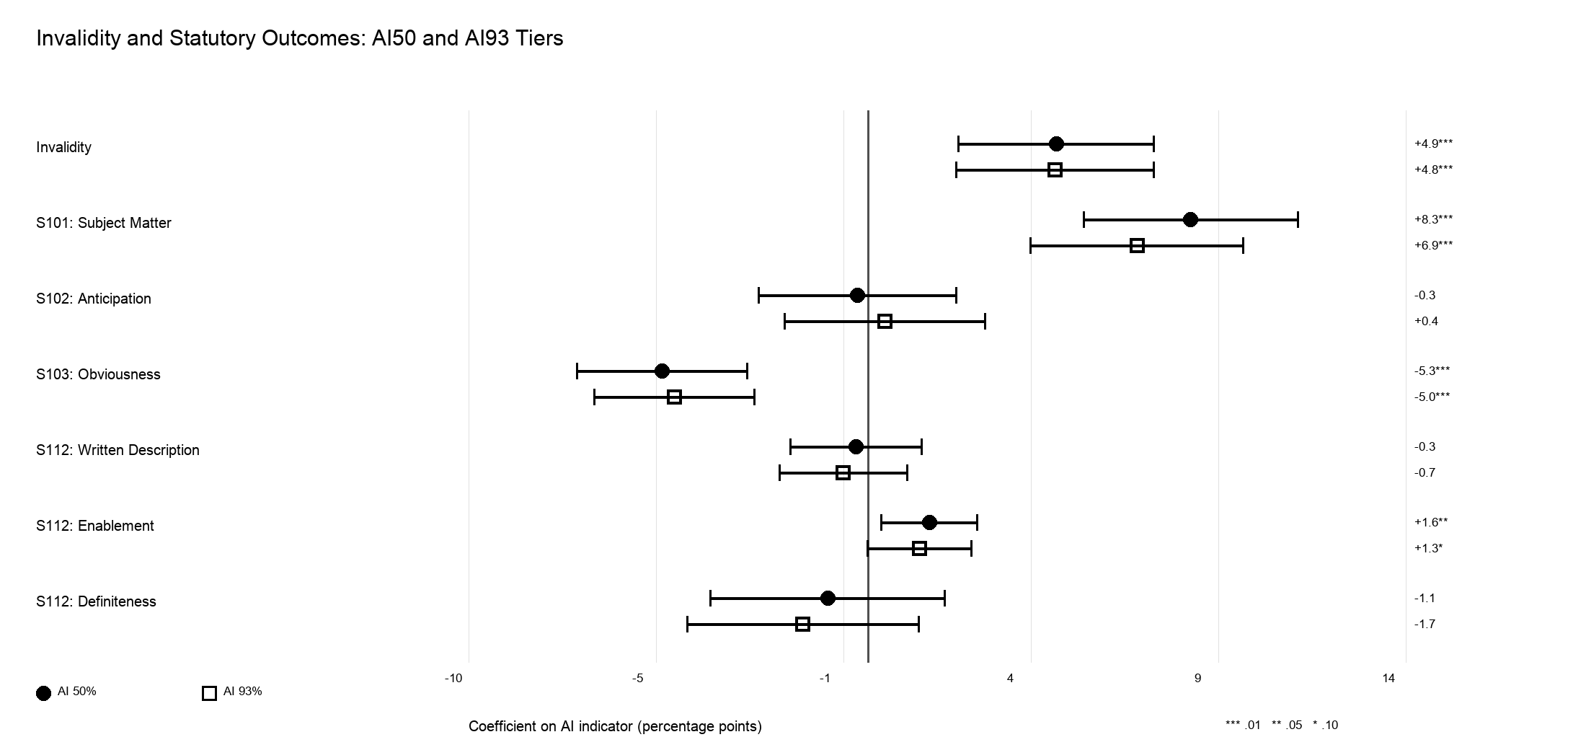
Table 5 then looks at the effect of Alice on the invalidity findings on section 101. Specifically, Model 1 adds a post-Alice indicator equal to one after June 19, 2014, and zero before that date. In Model 2, it also adds an interaction term between the post-Alice indicator and the AI indicator in some specifications. The non-interacted model answers, “Does the AI result surviving controlling for the post-Alice era?” By contrast, the interaction term answers, “did the AI gap itself change after Alice?” The results are stark: AI patents remain more likely to be invalidated under section 101 even after accounting for the general post-Alice increase in eligibility invalidations. The coefficient on the broad USPTO-AI indicator at 50% confidence is 8.09 percentage point, and the post-Alice indicator itself is 21.9 percentage points. This means two things are occurring: courts became more likely to use section 101 after Alice overall, and AI patents are still more likely to be invalidated than non-AI patents even after controlling for this broader doctrinal shift in eligibility law post-Alice. The interaction model is even more revealing. There, the AI coefficient before Alice is slightly negative: about -3.78 percentage points. But the AIxpost-Alice interaction term is 15.3 percentage points, so the implied post-Alice effect is 11.5 percentage points. In predicted probability terms, before Alice the model predicts section 101 invalidation probabiliites of about 25.6% for non-AI patents and 21.8% for AI patents. But after Alice, the probabilities rise to 42.0% for non-AI patents and 53.5% for AI patents. In plain terms, before Alice, AI patents were not especially more likely to be invalidated under section 101; after Alice, they were substantially more likely to be invalidated under section 101 than comparable non-AI patents. The same result persists when defining an AI invention at the higher 86% and 93% thresholds, as shown in Models 3 and 4. Figure 8 makes clear the difference.

Table 5: Section 101 and Alice
Statistic | Model 1  AI50, no interaction | Model 2  AI50, interaction | Model 3  AI93, no interaction | Model 4  AI93, interaction
AI coefficient | +8.09***  (1.40) | -3.78*  (2.28) | +6.68***  (1.40) | -3.63  (2.85)
Alpha | 0.01 | 0.10 | 0.01 | n.s.
Post-Alice coefficient | +21.88***  (3.85) | +16.43***  (3.86) | +21.97***  (3.88) | +19.22***  (3.80)
Post-Alice alpha | 0.01 | 0.01 | 0.01 | 0.01
AI x Post-Alice |  | +15.26***  (2.67) |  | +12.94***  (3.29)
Interaction alpha |  | 0.01 |  | 0.01
AI effect after Alice |  | +11.48***  (1.61) |  | +9.32***  (1.60)
Post-Alice AI alpha |  | 0.01 |  | 0.01
Pr(non-AI) | 37.6% |  | 39.0%
Pr(AI) | 45.7% |  | 45.6%
Pr(non-AI), pre-Alice |  | 25.6% |  | 25.1%
Pr(AI), pre-Alice |  | 21.8% |  | 21.5%
Pr(non-AI), post-Alice |  | 42.0% |  | 44.3%
Pr(AI), post-Alice |  | 53.5% |  | 53.6%

Figure 8: Coefficient Plot on Invalidity with Alice Post Control and Interaction

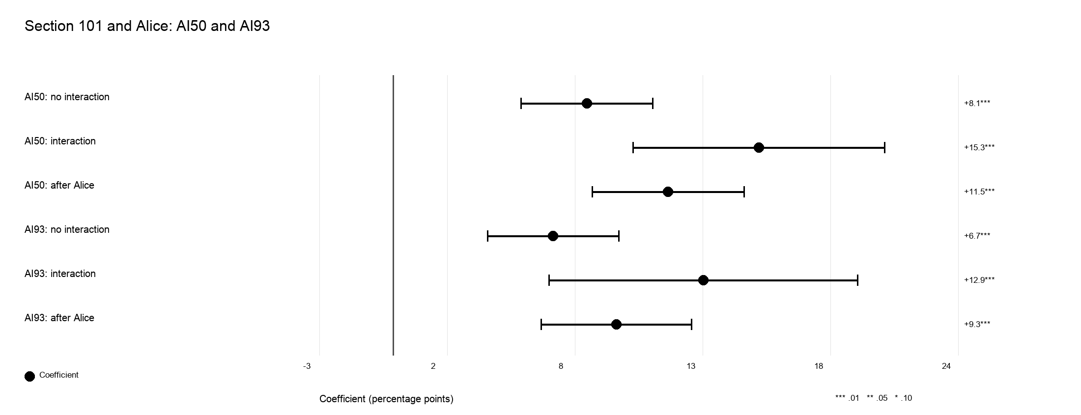

B. Non-Infringement
Table 6 shows that the infringement discrepancy for AI patents survives the same sequence of controls. Across all models, the AI indicator (again, defined in the main specification by the 50% threshold from the USPTO Database) is statistically significant at least at 99% confidence. In Model 1, with no controls, the non-AI baseline is 34.7%. The coefficient on the AI indicator is -10.69 percentage points, which corresponds to an adjusted probability of 24.0% for an AI invention. This represents a 30.8% decreased rate of infringement relative to the non-AI baseline. As with the invalidity outcomes, the numbers tighten as we add more controls. By the time we get to our preferred specification in Model 4 with all controls and fixed effects, there is a -4.60 percentage point decrease in infringement outcome for an AI patent. The adjusted probability falls from 33.5% for non-AI patents to 28.9% for AI patents. While this difference is still statistically significant at 99% confidence, it is smaller than the invalidity results and thus should be taken with a grain of salt. AI patents are thus not merely more likely to lose somewhere in the litigation process; they are also less likely to end in an infringement finding even after the model compares them within similar courts, years, technologies, and procedural settings.

Table 6: Infringement at AI Tier 50%
Statistic | Model 1 | Model 2 | Model 3 | Model 4
AI coefficient | -10.69***  (1.46) | -10.33***  (1.49) | -9.78***  (1.29) | -4.60***  (1.42)
Alpha | 0.01 | 0.01 | 0.01 | 0.01
Pr(non-AI) | 34.7% | 34.6% | 34.5% | 33.5%
Pr(AI) | 24.0% | 24.3% | 24.7% | 28.9%
Relative change | -30.8% | -29.8% | -28.3% | -13.7%
N | 6,362 | 6,362 | 6,362 | 6,362
R2 | 0.008 | 0.041 | 0.236 | 0.288
Cells report coefficient in percentage points, with patent-clustered standard error in parentheses.

Table 7 shows the results defining an AI invention at increasingly higher levels of confidence. In all specifications, the results remain the same: an invention classified as an AI invention by the USPTO Database is less likely to be found infringed to a statistically significant degree, even in models with all controls. Figure 9 makes clear the differences.

Table 7: Infringement Across AI Tiers
Statistic | AI Tier 50% | AI Tier 86% | AI Tier 93%
AI coefficient | -4.60***  (1.42) | -4.61***  (1.54) | -4.99***  (1.60)
Alpha | 0.01 | 0.01 | 0.01
Pr(non-AI) | 33.5% | 33.3% | 33.3%
Pr(AI) | 28.9% | 28.7% | 28.3%
Relative change | -13.7% | -13.8% | -15.0%
N | 6,362 | 6,362 | 6,362
R2 | 0.288 | 0.288 | 0.288
Cells report coefficient in percentage points, with patent-clustered standard error in parentheses.

Figure 9: Coefficient Plot on Infringement Across AI Tiers
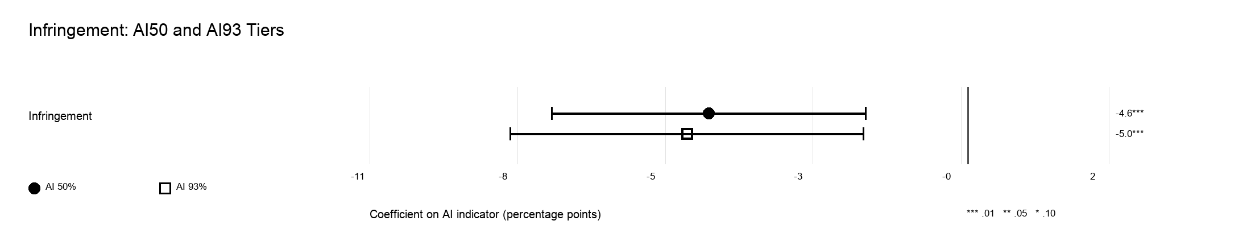
C. Is It Really AI, or Just Software?
The central identification concern is whether the AI effect merely reflects the well-documented fragility of software patents. Because most AI patents are a subset of software, a naive AI indicator could conflate two mechanisms: the general post-Alice fragility of software and any added risk specific to AI. To separate them, in a first robustness check, I partition patents into three mutually exclusive groups, namely AI patents, software patents not classified as AI, and non-software patents, using the software CPC classes standard in the literature (G06F, G06Q, and related data-processing classes). I use CPC classifications as the principal software measure because CPC primary subsections provide a more conservative technological classification that a WIPO-based definition. I then re-estimate the baseline models on the software-only sample with both an AI-patent indicator and a non-AI-software indicator, with non-software patents omitted. If the AI coefficient survives within software, the disparity evidenced in the prior section is not merely software fragility. This is so because restricting the comparison to software-relevant CPC classes creates a within-technology contrast between AI software and ordinary software, so the AI indicator no longer captures the difference between software and everything else. It captures only the difference within software. If post-Alice software fragility were the whole story, then once a separate software indicator is in the model, the AI coefficient should fall toward zero, because there would be nothing left for it to explain. A surviving AI coefficient means the opposite: that courts are responding to something about AI claims that ordinary software claims do not share.
I run the comparison under different software definitions of software and at different USPTO AI confidence thresholds, so that the result cannot rest on a single way of drawing the software boundary or the AI boundary. I construct separate measures for software and digital communications from both CPC and WIPO. In alternative specifications, I used both broad and narrow definitions of what constitutes software. For simplicity, in the tables and charts below I report the results using the broad software indicator for CPC and WIPO though the results are similar for the narrow indicator.
Table 8 shows that the results are robust to different definitions of software. In particular, the invalidity results are statistically significant for the AI patent indicator. Under the broad software definition at the 50% AI confidence tier, the adjusted probability of invalidity rises from 67.1% for non-AI software patents to 72.4% for AI software patents. In short, while the invalidity effect weakens once the comparison is limited to software patents, the gap is still there and statistically significant at 99% confidence levels. Table 9 shows the results broken down by statutory section. The section 101 subject matter findings are even more revealing: for broad software patents that are invalidated, the adjusted probability of a section 101 invalidity ground rises from 57.9% for a non-AI patent to 64.8% for an AI patent. The obviousness result here, however, is much weaker substantively and is only statistically significant at 90% confidence. The adjusted probability of a section 103 ground decreases from 7.6% for a non-AI patent to 5.3% for an AI patent. In all, the results that AI inventions are treated differently than non-AI inventions in terms of invalidity, particularly for section 101, survives even when the sample is limited to software only cases.

Table 8: Invalidity in Software Samples
Statistic | CPC 50% | CPC 86% | CPC 93% | WIPO 50% | WIPO 86% | WIPO 93%
AI coefficient | +5.28***  (1.64) | +4.51***  (1.56) | +4.65***  (1.51) | +5.72***  (1.42) | +5.28***  (1.37) | +4.89***  (1.36)
Alpha | 0.01 | 0.01 | 0.01 | 0.01 | 0.01 | 0.01
Pr(non-AI) | 67.1% | 68.1% | 68.3% | 64.5% | 65.4% | 65.7%
Pr(AI) | 72.4% | 72.6% | 72.9% | 70.3% | 70.6% | 70.6%
Relative change | +7.9% | +6.6% | +6.8% | +8.9% | +8.1% | +7.4%
N | 1,893 | 1,893 | 1,893 | 2,801 | 2,801 | 2,801
R2 | 0.560 | 0.559 | 0.559 | 0.517 | 0.516 | 0.516
Columns combine CPC broad and WIPO broad definitions. N is reported as a row for each column-specific estimation sample.

Table 9: CPC/WIPO Statutory Chart in Software Samples at AI Tier 50%
Reference / Statistic | S101  Subject Matter | S102  Anticipation | S103  Obviousness | S112  Written Desc. | S112  Enablement | S112  Definiteness
CPC - AI coefficient | +6.88***  (1.99) | +0.79  (1.47) | -2.35*  (1.20) | -1.98*  (1.06) | +0.55  (0.66) | -1.45  (2.15)
CPC - Alpha | 0.01 | n.s. | 0.10 | 0.10 | n.s. | n.s.
CPC - Pr(non-AI) | 57.9% | 9.7% | 7.6% | 3.9% | 1.2% | 24.3%
CPC - Pr(AI) | 64.8% | 10.5% | 5.3% | 1.9% | 1.7% | 22.8%
CPC – N | 1,328 | 1,328 | 1,328 | 1,328 | 1,328 | 1,328
CPC - R2 | 0.662 | 0.450 | 0.405 | 0.131 | 0.113 | 0.517
WIPO - AI coefficient | +7.37***  (1.57) | +0.29  (1.36) | -3.37***  (1.18) | -0.80  (0.93) | +1.69***  (0.63) | -2.17  (1.75)
WIPO - Alpha | 0.01 | n.s. | 0.01 | n.s. | 0.01 | n.s.
WIPO - Pr(non-AI) | 52.9% | 11.7% | 10.1% | 4.0% | 1.1% | 25.3%
WIPO - Pr(AI) | 60.3% | 12.0% | 6.7% | 3.2% | 2.8% | 23.2%
WIPO - N | 1,891 | 1,891 | 1,891 | 1,891 | 1,891 | 1,891
WIPO - R2 | 0.674 | 0.386 | 0.390 | 0.191 | 0.211 | 0.486
The statutory sections are the columns. Rows identify the CPC or WIPO taxonomy reference and the reported statistic. Coefficients are percentage points with patent-clustered standard errors in parentheses.

The infringement estimates in Table 10 in the software subsample are negative and noticeably weaker. Further, the results are not statistically significant in most specifications. The broad software model predicts infringement probabilities of 25.3% for non-AI software patents and 23.0% for AI software patents, a very narrow difference. This result is not unexpected. Rather, it just reflects the fact that the AI infringement disadvantage observed earlier is concentrated outside software patents. It may reflect difficulty proving accused products practice AI-related claim limitations in more heterogenous technical fields, especially where the patented invention is framed around system functionality, sensing, control, automation, or data-processing behavior that is harder to map onto an accused device or process. Further, it may be that AI alters the nature of technological competition primarily in traditionally non-software industries, where AI functionality is often embedded within physical systems, where it is less readily observable, and more susceptible to alternative implementations. Within software, by contrast, AI represents an incremental variation on existing algorithmic technologies rather than a distinct mode of innovation. As a result, AI software patents appear to resemble software patents generally with respect to infringement outcomes.

Table 10: Infringement in Software Samples
Statistic | CPC 50% | CPC 86% | CPC 93% | WIPO 50% | WIPO 86% | WIPO 93%
AI coefficient | -2.29  (1.99) | -1.42  (1.95) | -1.38  (2.01) | -3.12*  (1.63) | -2.46  (1.66) | -2.51  (1.70)
Alpha | n.s. | n.s. | n.s. | 0.10 | n.s. | n.s.
Pr(non-AI) | 25.3% | 24.7% | 24.7% | 25.6% | 25.1% | 25.1%
Pr(AI) | 23.0% | 23.3% | 23.3% | 22.5% | 22.7% | 22.5%
Relative change | -9.0% | -5.7% | -5.6% | -12.2% | -9.8% | -10.0%
N | 1,524 | 1,524 | 1,524 | 2,509 | 2,509 | 2,509
R2 | 0.432 | 0.432 | 0.432 | 0.367 | 0.366 | 0.366
Columns combine CPC broad and WIPO broad definitions. N is reported as a row for each column-specific estimation sample.

Figure 10 in turn make clear the patterns for this software-only robustness check.

Figure 10: Merits and Statutory Outcome: Software Sample

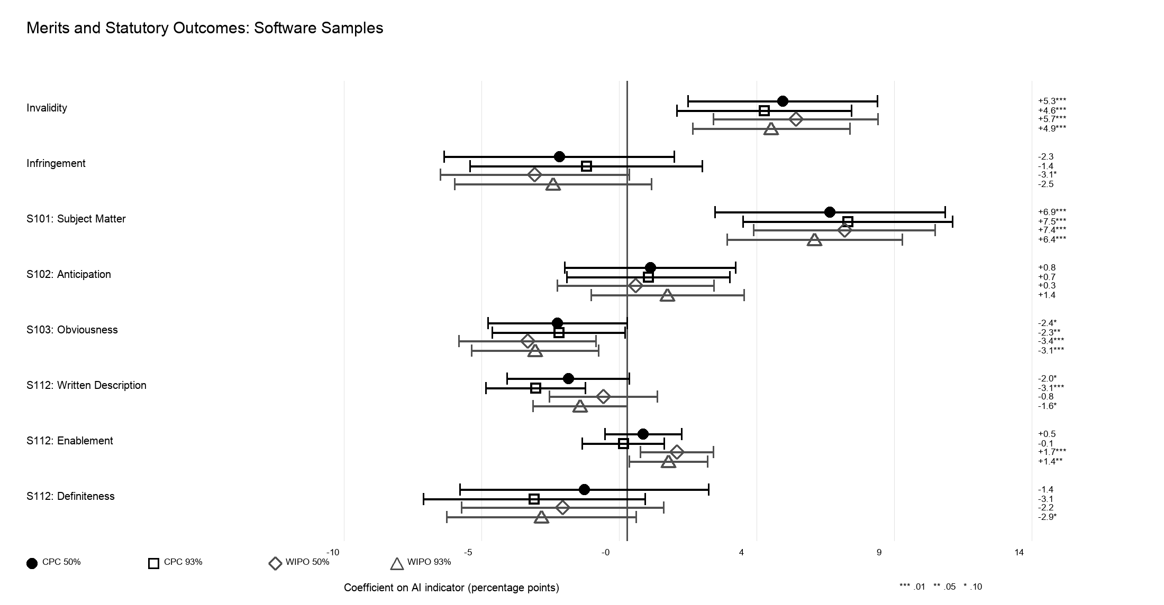

In a second robustness check, I limit the sample to specifically exclude software and telecommunications patents. This shrinks the sample almost in half. These remaining patents are mostly in instrumentation/vision, physics, electronics, medical devices, transportation, consumer technologies, and some industrial categories. Despite that, the results in Table 11 noted on invalidity above survive even on the limited universe of clearly-non software and non-telecommunications patents labeled as AI by the USPTO: AI patents remain significantly more likely to be invalidated under section 101 and significantly less likely to be invalidated under section 103. With respect to invalidity overall, the adjusted non-AI invalidation probability is 47.5% compared to 55.0% for AI inventions at the 50% confidence tier. This gap actually widens when the probability of a patent being an AI patent is increased. At the 93% confidence tier, the adjusted probability for a non-AI invention is 47.8% for non-AI inventions compared to 57.2% for AI inventions.

Table 11: Invalidity in Non-software Samples
Statistic | CPC 50% | CPC 86% | CPC 93% | WIPO 50% | WIPO 86% | WIPO 93%
AI coefficient | +7.46***  (1.92) | +9.03***  (2.08) | +9.41***  (2.16) | +7.50***  (2.81) | +10.18***  (3.33) | +11.68***  (3.52)
Alpha | 0.01 | 0.01 | 0.01 | 0.01 | 0.01 | 0.01
Pr(non-AI) | 47.5% | 47.7% | 47.8% | 43.9% | 44.0% | 44.0%
Pr(AI) | 55.0% | 56.7% | 57.2% | 51.4% | 54.2% | 55.7%
Relative change | +15.7% | +18.9% | +19.7% | +17.1% | +23.1% | +26.5%
N | 3,858 | 3,858 | 3,858 | 2,950 | 2,950 | 2,950
R2 | 0.319 | 0.319 | 0.319 | 0.289 | 0.289 | 0.290
Columns combine CPC broad and WIPO broad definitions. N is reported as a row for each column-specific estimation sample.

It is the same story when limited to only section 101 or section 103 invalidations, although the results are nearly identical at both high and low AI confidence tiers. As shown in Table 12, for section 101, the adjusted probability for a non-AI invention is 23.2% compared to 34.0% for AI inventions measured at the 50% confidence tier. The breakdown is similar for section 103 invalidations, but in the oppositive direction (26.7% and 19.1% respectively). This suggests a doctrinal substitution story: among patents already found invalid, non-software AI patents are still more likely to be invalidated as claiming ineligible abstraction/functionality, and less often invalidated as ordinary combinations of prior art. In other words, the AI effect observed above is not clearly an Alice/software effect. Rather, courts appear to treat AI-enabled patents across a broad set of technical fields as presenting invalidity problems. The differences are even more stark under the WIPO definition of software. There, the adjusted probability for a non-AI patent is 29.7% compared to 15.4% for an AI patent, a large 93.5% relative increase.

Table 12: CPC/WIPO Statutory Chart in Non-software Samples at AI Tier 50%
Reference / Statistic | S101  Subject Matter | S102  Anticipation | S103  Obviousness | S112  Written Desc. | S112  Enablement | S112  Definiteness
CPC - AI coefficient | +10.76***  (2.01) | -3.76*  (2.16) | -7.59***  (1.87) | +1.48  (1.38) | +1.90  (1.16) | +0.25  (2.22)
CPC - Alpha | 0.01 | 0.10 | 0.01 | n.s. | n.s. | n.s.
CPC - Pr(non-AI) | 23.2% | 26.2% | 26.7% | 7.0% | 4.7% | 23.3%
CPC - Pr(AI) | 34.0% | 22.5% | 19.1% | 8.4% | 6.6% | 23.6%
CPC - N | 1,878 | 1,878 | 1,878 | 1,878 | 1,878 | 1,878
CPC - R2 | 0.684 | 0.275 | 0.351 | 0.170 | 0.175 | 0.388
WIPO - AI coefficient | +14.38***  (3.12) | -3.77  (3.38) | -9.33***  (3.00) | -1.73  (2.02) | -1.11  (1.71) | -0.41  (3.45)
WIPO - Alpha | 0.01 | n.s. | 0.01 | n.s. | n.s. | n.s.
WIPO - Pr(non-AI) | 15.4% | 30.0% | 31.3% | 8.3% | 5.9% | 22.4%
WIPO - Pr(AI) | 29.7% | 26.2% | 22.0% | 6.5% | 4.8% | 22.0%
WIPO - N | 1,315 | 1,315 | 1,315 | 1,315 | 1,315 | 1,315
WIPO - R2 | 0.620 | 0.277 | 0.336 | 0.165 | 0.178 | 0.392
The statutory sections are the columns. Rows identify the CPC or WIPO taxonomy reference and the reported statistic. Coefficients are percentage points with patent-clustered standard errors in parentheses.
Figure 13 displays the data in the non-software sample

Figure 11: Merits and Statutory Outcomes: Non-Software Sample

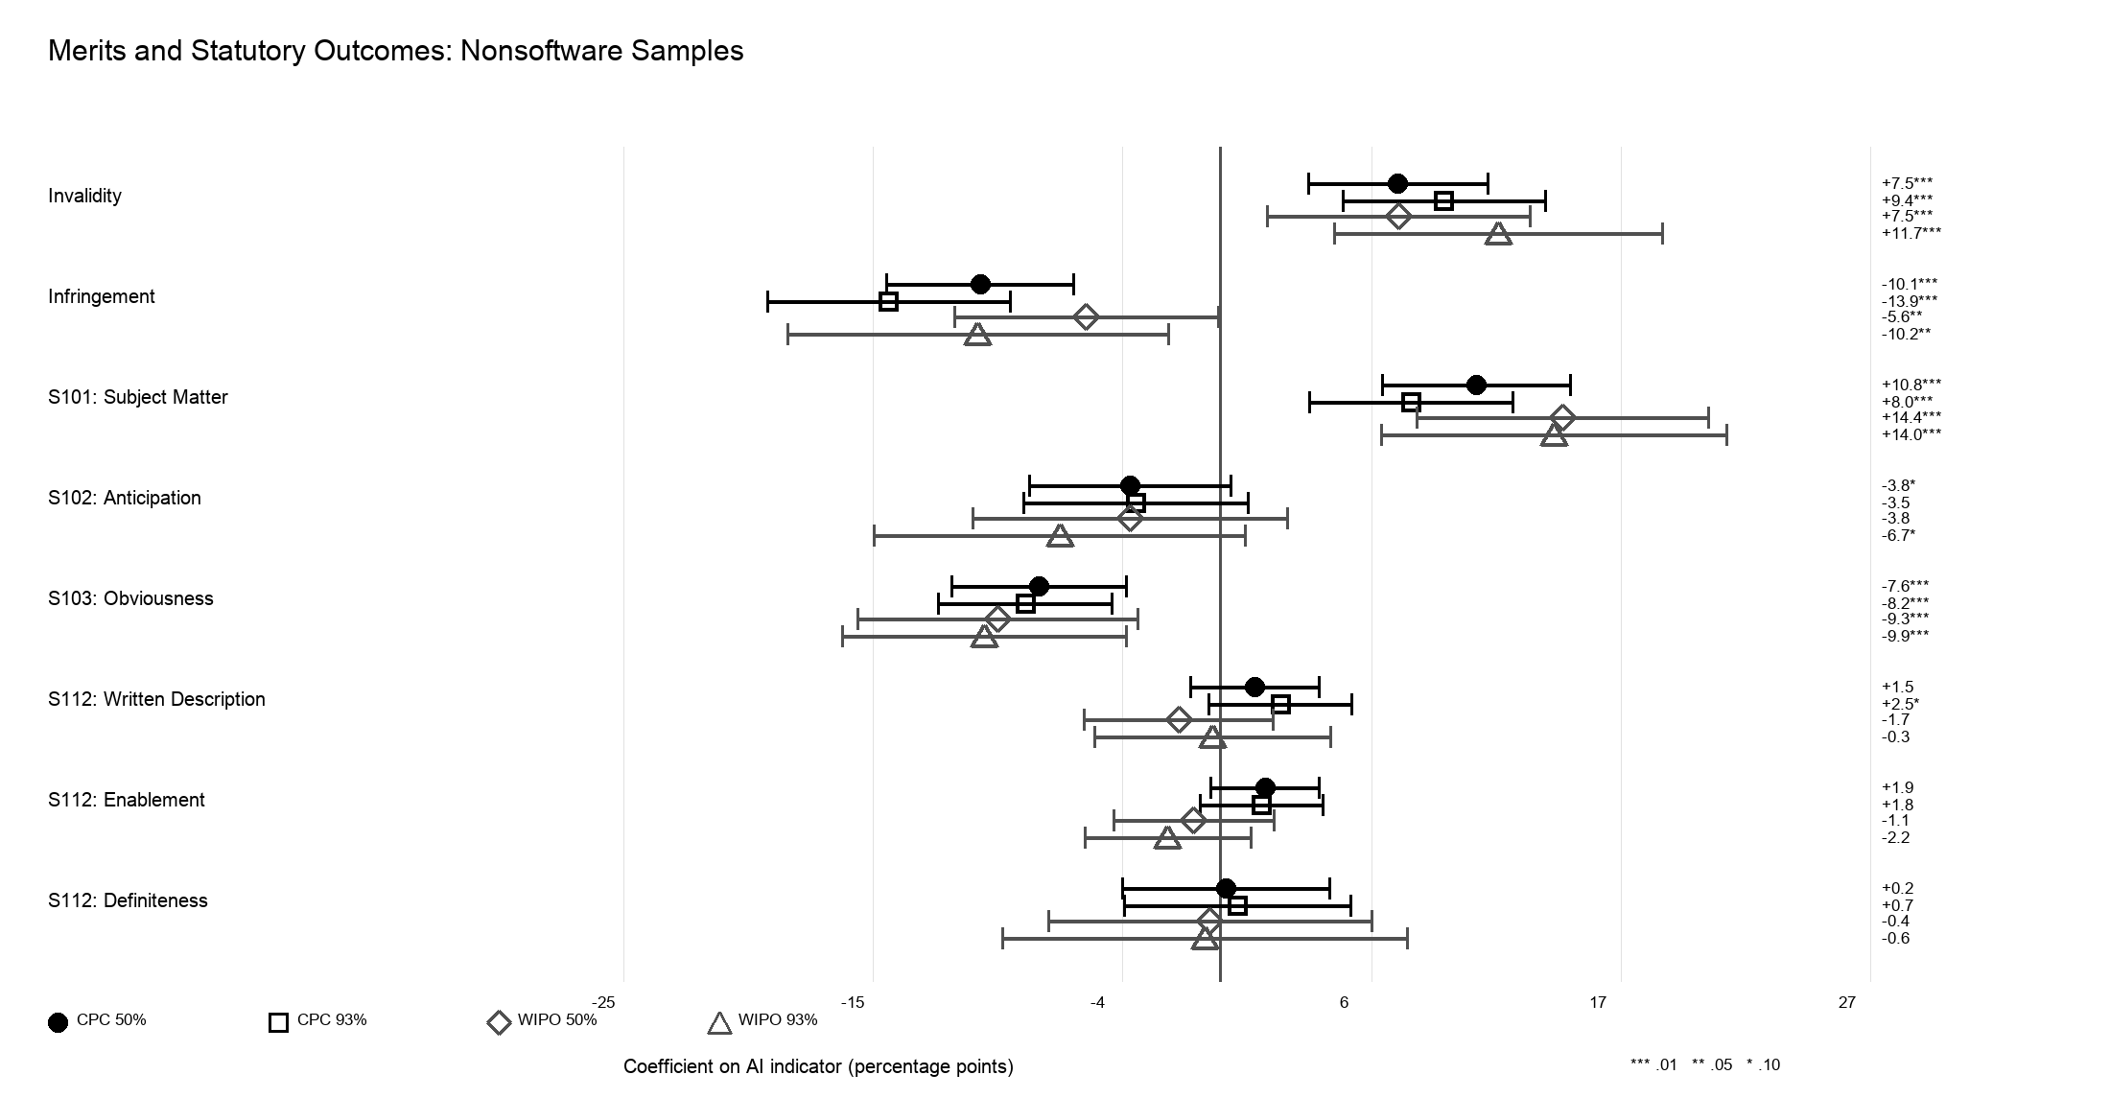
When software patents are removed from the sample, the AI infringement gap gets larger and more statistically significant. In contrast to the software-only sample where the AI indicator on infringement is not statistically significant, Table 13 makes plain that when the sample is expressly limited to non-software patents, AI inventions are in fact less likely to be proved infringed than non-AI patents. The predicted infringement falls from 36.3% for non-AI to 26.3% for AI inventions at the 50% confidence tier on the CPC definition. The difference is even steeper for higher-confidence AI inventions. At the 93% confidence tier, the adjusted probability falls from 36.1% for non-AI inventions to just 22.2% for AI inventions. Results are similar but with a smaller gap using the WIPO definition of software. As noted above, however, this just merely reflects that the infringement penalty for AI inventions is not a software/Alice story; rather it is concentrated in non-software fields which is what one might expect.

Table 13: Infringement in Non-software Samples
Statistic | CPC 50% | CPC 86% | CPC 93% | WIPO 50% | WIPO 86% | WIPO 93%
AI coefficient | -10.07***  (2.01) | -12.57***  (2.47) | -13.90***  (2.61) | -5.61**  (2.83) | -9.54**  (3.77) | -10.16**  (4.08)
Alpha | 0.01 | 0.01 | 0.01 | 0.05 | 0.05 | 0.05
Pr(non-AI) | 36.3% | 36.1% | 36.1% | 38.4% | 38.3% | 38.3%
Pr(AI) | 26.3% | 23.5% | 22.2% | 32.7% | 28.8% | 28.1%
Relative change | -27.7% | -34.8% | -38.5% | -14.6% | -24.9% | -26.5%
N | 4,838 | 4,838 | 4,838 | 3,853 | 3,853 | 3,853
R2 | 0.254 | 0.254 | 0.254 | 0.254 | 0.254 | 0.254
Columns combine CPC broad and WIPO broad definitions. N is reported as a row for each column-specific estimation sample.
Set against the invalidity results, the evidence points to a consistent asymmetry. AI software patents face elevated invalidation risk even among software patents. At the same time, AI patents enjoy lower infringement success especially when limited to non-software patents. That combination fits a doctrinal environment particularly skeptical of AI inventions, and it suggests the patent system may be imposing a double hurdle on AI claims: harder to keep alive, and harder to enforce once alive. The stability of the gap across the different software definitions and increasingly higher AI confidence thresholds further weakens the pure-software explanation. The AI indicator retains incremental explanatory power conditional on software controls and rich fixed effects, which is what one would expect if courts are reacting to features specific to AI-type claims rather than to software in general. Modern doctrine, then, treats AI inventions as a distinct risk category within software. Traditional software patents already face headwinds, but AI software faces an additional penalty that software classification alone cannot explain.
IV. Doctrinal Implications and Reform
The patterns documented in this study point to a mismatch between legacy patent doctrine and the structure of modern AI. AI patents meet disproportionate pressure at the patentability stage, particularly under § 101 and to a lesser extent § 103, yet once they clear those filters they are comparatively hard to defeat on noninfringement grounds. The system is not simply treating AI inventions as stronger or weaker than other technologies. It is applying doctrinal tools that fit unevenly across the phases of a case. The aim should not be to privilege AI patents but to calibrate screening and adjudication to the informational and technical structure of machine-learning innovation. Five interventions follow from the findings, running from doctrinal housekeeping at the Federal Circuit to a structural reset of eligibility in Congress.
1. Federal Circuit guidance on how § 101 applies to machine-learning claims
The Federal Circuit should supply granular guidance on how § 101 applies to data-driven learning systems. The case law grew up around business-method and conventional software claims and does not map cleanly onto architectures that combine data preprocessing, model training, and hardware implementation. The concentration of risk in AI inventions shows that algorithmic patents stay especially exposed to characterization at Alice step one, where the two-step framework leaves wide room for panel-level variation. Courts should distinguish more explicitly between claims that merely invoke generic data analysis and claims that recite concrete technological pipelines for training and deploying models. There is a workable line. The court could separate claims directed to disembodied mathematical relationships from claims directed to applied computational systems that produce a concrete technological result, and could give content to step two by identifying the disclosures that supply an inventive concept in this setting, such as a specific architecture, a described training method, or a concrete improvement in how the system runs. Clarity at this stage would curb excessive early invalidation while preserving the gatekeeping function of eligibility, all without an act of Congress.
2. Rebalance § 101 against § 112
Courts and Congress should rebalance § 101 against § 112. The uniformly low and non-statistically significant § 112 invalidation rates in the data show that courts are not leaning on enablement or written description or indefiniteness to police AI claim breadth, even though overbreadth is the underlying concern that abstraction doctrine is so often used to reach. Several scholars argue that overbreadth in software and AI patents is better addressed through rigorous enablement analysis than through a threshold legal characterization of abstractness, because enablement asks the fact-intensive question that actually matters: whether the specification teaches a skilled reader how to make and use the full scope of what is claimed. A § 112-first approach in AI cases would reserve § 101 for truly preemptive or purely mathematical claims and resolve overbreadth through enablement and written description. Because the AI penalty is overwhelmingly an eligibility penalty and almost never a disclosure one, a shift toward § 112 would not merely relocate the same outcomes. It would force the overbreadth question to be litigated on a record about the technology rather than decided on the pleadings.
3. Eliminate the judicial exceptions and let §§ 102, 103, and 112 do the work
Most ambitiously, Congress should eliminate the judicial exceptions to § 101 and let the rest of the Patent Act do the screening work. The abstract-idea exception has proven unpredictable and difficult to administer. Section 101 contains no express exclusion for abstract ideas. The exception is a judicial gloss whose historical foundations several scholars have questioned. Federal Circuit judges have said as much. Judge Plager called the abstract-idea inquiry “a definitional morass” that renders it “near impossible to know with any certainty whether the invention is or is not patent eligible.” The full court divided evenly in American Axle, warning that its eligibility rulings had “become so diverse and unpredictable as to have a serious effect on the innovation incentive in all fields of technology,” and in Athena Diagnostics eight separate opinions accompanied the denial of rehearing. The Patent Eligibility Restoration Act would abrogate the judge-made exceptions and replace them with a closed list of statutory exclusions, and bar courts from smuggling novelty, obviousness, and disclosure considerations into the eligibility inquiry. My findings supply the empirical case the debate has lacked. AI patents are not measurably weaker on novelty or disclosure, yet § 101 invalidates them at sharply higher rates. Further, for obviousness inquiries, it invalidates AI patents at significantly lower rates. Removing the abstract-idea screen would not leave AI patents unexamined. It would push the inquiry onto § 102, § 103, and § 112, each of which asks a fact-bound question on a developed record instead of a threshold legal characterization on the pleadings. The reform is not costless. It works only if courts are willing to make § 112 and § 103 carry real weight, which the low § 112 invalidation rates in my data suggest they have not yet been.
The statistically significant though less substantively robust findings on section 103 have broader implications for the continuing debate over patent eligibility. Since Alice, scholars have argued that § 101 has displaced the more technologically grounded inquiries of §§ 102, 103, and 112. The evidence here provides empirical support for that concern. Obviousness is the Patent Act’s principal mechanism for distinguishing genuine technological advances from routine combinations of existing knowledge. Unlike § 101, it requires courts to evaluate the state of the prior art, the level of ordinary skill, and the technical contribution of the claimed invention on a developed factual record. If AI patents are disproportionately resolved under § 101 instead of § 103, courts may be substituting a threshold characterization of abstraction for the substantive inquiry Congress designed to evaluate inventiveness. Whether that substitution produces better outcomes is ultimately a normative question beyond the scope of this Article. The empirical evidence, however, suggests that modern AI litigation is increasingly decided through eligibility rather than through obviousness.
If the evidence reflects a doctrinal substitution from § 103 to § 101, the institution best positioned to respond is the Federal Circuit. Congress designed § 103 to distinguish genuine technological advances from routine combinations of prior art through a fact-intensive inquiry into the state of the art, the level of ordinary skill, and the claimed inventive contribution. Yet the data suggest that many AI patents never receive that analysis because they are instead resolved at the threshold under § 101. The Federal Circuit could recalibrate that balance without abandoning Alice. Courts could reserve eligibility for claims that truly seek to monopolize abstract ideas while directing closer questions about the technical significance of AI inventions toward the statutory inquiries of obviousness and disclosure. Such an approach would not weaken patent-quality review. Rather, it would ensure that AI patents are evaluated under the doctrinal provisions specifically designed to assess whether an invention represents a genuine technological advance. The result would be a patent system that screens AI inventions based less on categorical judgments about abstraction and more on the technical merits of the claimed innovation.
4. USPTO examination guidance tailored to AI
The USPTO as the institution best positioned to act quickly should issue examination guidance tailored to AI. Because the Office already screens at examination, clearer guidance on AI eligibility, particularly around training methods and applied AI systems, could dampen downstream litigation volatility. AI claims need more detail about how the AI operates and how it interacts with the rest of the invention. That detail both keeps the claim from reading as an abstract idea and helps the patentee survive a definiteness challenge. Where training data are used, the claims and specification should show how the data are used, identifying the algorithms, models, and techniques that develop the training data and how they contribute to the technical solution. The Office and the courts could state clearer expectations for what adequate disclosure of a machine-learning system requires, which would improve predictability for applicants while preserving the disclosure function of the patent.
5. Procedural and doctrinal modernization at the infringement stage
The infringement stage needs procedural and doctrinal modernization. The difficulty parties face in proving infringement in AI cases reflects informational asymmetries around proprietary models. Traditional infringement adjudication assumes that accused functionality can be inspected and compared against the claim limitations, and that assumption strains against opaque or continuously updated machine-learning systems. Courts should consider structured early-disclosure protocols for AI cases, with staged production of model-architecture information, training-pipeline descriptions, and relevant source code under appropriately calibrated protective orders, and greater use of neutral technical experts in the most complex disputes. Infringement doctrine itself may need to adapt. Because some infringing activity is only momentary, the law will have to decide whether transient infringement counts at all, and divided and indirect infringement raise the harder version of the same problem when a model is built, sold, trained, and operated by different parties.
The litigation process will have to adapt as well. AI litigation threatens enormous discovery reaching the past and future operation of AI systems and the training sets used to build them. The history of electronic discovery offers a template for cost-shifting when one party is inundated with electronic material. These are reasons for courts and, if needed, Congress to decide deliberately how the existing provisions apply to AI rather than leaving the questions to be answered case by case in the districts that happen to draw the cases.
Underneath these reforms sits a deeper question about innovation policy. If AI patents face elevated § 101 risk even under narrow definitions of AI, current doctrine may be falling hardest on upstream, foundational technologies rather than downstream applications. The rise of AI is not a wholesale crisis for patent law but a calibration problem. The existing toolkit can handle AI inventions, but only if it is applied with closer attention to the informational structure of machine-learning systems, and the evidence developed in the study marks the institutional margins, the Federal Circuit, the USPTO, and Congress, where modest, targeted reform could do the most good.
Conclusion
This Article set out to answer an empirical question that had drawn a great deal of assertion and little evidence: do AI patents fare worse in district court than other inventions, and if so, why. The answer is that they do, and that the why is more specific than the policy debate has assumed. AI patents are more likely to be invalidated and less likely to be found infringed than comparable non-AI patents, the effects are large and stable across definitions and thresholds, and they survive the comparison within software. The validity penalty is an eligibility penalty, concentrated in § 101 and to a lesser extent section 103. The infringement penalty has a different source, the difficulty of observing and attributing the behavior of opaque, distributed systems, and it concentrates where that difficulty is greatest, particularly among non-software inventions.
Those findings do not dictate a single reform. They make the case for clarifying how eligibility applies to machine-learning claims, for shifting the overbreadth inquiry toward the fact-based provisions that were built for it, and, for reconsidering whether the judge-made exceptions to § 101 should continue to do the work that §§ 102, 103, and 112 could do on a developed record. They also separate the eligibility problem from the infringement problem, which a single reform cannot solve together. AI litigation will only become more common, and the patent system will be answering these questions whether or not it does so deliberately.

I would like to thank participants at the Intellectual Property Scholars Conference, the AALS New Voices in IP conference, PATCON, WIPIP and the NYU Engelberg Center’ Tri-State IP conference for their helpful comments on my paper. I would also like to thank research assistant Justin Hill and the editors and staff at Indiana Law Review including Abigail Weick, Jena Berger and ____[add names].
See generally U.S. Pat. & Trademark Off., Inventing AI: Tracing the Diffusion of Artificial Intelligence with U.S. Patents (2020) [hereinafter Inventing AI], https://www.uspto.gov/sites/default/files/documents/OCE-DH-AI.pdf; Ian Bremmer, How the World Must Respond to the AI Revolution, Time (May 31, 2023), https://time.com/6283716/world-must-respond-to-the-ai-revolution/; Klaus Schwab, The Fourth Industrial Revolution: What It Means, How to Respond, World Econ. F. (Jan. 14, 2016), https://www.weforum.org/stories/2016/01/the-fourth-industrial-revolution-what-it-means-and-how-to-respond.
See Patent Act of 1952, Pub. L. No. 82-593, 66 Stat. 792; Leahy-Smith America Invents Act, Pub. L. No. 112-29, 125 Stat. 284 (2011).
See, e.g., James Bessen & Michael J. Meurer, Patent Failure: How Judges, Bureaucrats, and Lawyers Put Innovators at Risk (2008).
Alice Corp. v. CLS Bank Int’l, 573 U.S. 208 (2014).
35 U.S.C. § 101.
Paul R. Gugliuzza, Quick Decisions in Patent Cases, 106 Geo. L.J. 619, 645–55 (2018).
See sources cited infra note 8.
See, e.g., David O. Taylor, Confusing Patent Eligibility, 84 Tenn. L. Rev. 157, 159–65 (2016); John R. Allison, Mark A. Lemley & David L. Schwartz, Our Divided Patent System, 82 U. Chi. L. Rev. 1073, 1110–20 (2015); Gugliuzza, supra note 6, at 646–55; Amy Semet, Comparison of Outcomes at the PTAB and District Courts (forthcoming).
Rai, supra note 15, at 2622–27; see also Cockburn, Henderson & Stern, supra note 34, at 125.
Alexander V. Giczy, Nicholas A. Pairolero & Andrew A. Toole, Identifying Artificial Intelligence (AI) Invention: A Novel AI Patent Dataset, at 2 (U.S. Pat. & Trademark Off., Econ. Working Paper No. 2021-02, 2021); see also Org. for Econ. Co-operation & Dev., Explanatory Memorandum on the Updated OECD Definition of an AI System (OECD Artificial Intelligence Papers No. 8, 2024), https://www.oecd.org/en/publications/explanatory-memorandum-on-the-updated-oecd-definition-of-an-ai-system_623da898-en.html.
See, e.g., Kevin J. Hickey, Patent-Eligible Subject Matter Reform: Background and Issues for Congress, Cong. Rsch. Serv. No. R45918, at 6–7, 16–21 (Mar. 31, 2025) (describing multiple § 101 reform bills, including versions of the Patent Eligibility Restoration Act).
See Diamond v. Diehr, 450 U.S. 175, 185 (1981).
Alice Corp. v. CLS Bank Int’l, 573 U.S. 208, 217–18 (2014).
Compare Elec. Power Grp., LLC v. Alstom S.A., 830 F.3d 1350, 1353–56 (Fed. Cir. 2016), with Enfish, LLC v. Microsoft Corp., 822 F.3d 1327, 1335–40 (Fed. Cir. 2016); see also McRO, Inc. v. Bandai Namco Games Am. Inc., 837 F.3d 1299, 1313–16 (Fed. Cir. 2016); Finjan, Inc. v. Blue Coat Sys., Inc., 879 F.3d 1299, 1303–06 (Fed. Cir. 2018).
See, e.g., Jay P. Kesan & Runhua Wang, Eligible Subject Matter at the Patent Office: An Empirical Study of the Influence of Alice on Patent Examiners and Patent Applicants, 105 Minn. L. Rev. 527, 568–76 (2020); Matthew Sipe, Patent Law 101: I Know It When I See It, 37 Harv. J.L. & Tech. 1, 4–8, 54–69 (2023); Arti K. Rai, Machine Learning at the Patent Office: Lessons for Patents and Administrative Law, 104 Iowa L. Rev. 2617, 2622–27 (2019).
35 U.S.C. § 102(a)(1).
35 U.S.C. § 103; see Graham v. John Deere Co., 383 U.S. 1, 17–18 (1966).
35 U.S.C. § 112(a)–(b).
Id.
35 U.S.C. § 112(a)–(b); see W. Keith Robinson, Enabling Artificial Intelligence, 60 Hous. L. Rev. 331 (2022).
35 U.S.C. § 271(a)-(c). A potential infringer can also sue for a declaratory judgement of non-infringement or invalidity, for example.
35 U.S.C. § 311(a)–(b). Inter partes review lets a third party challenge an issued patent in a streamlined, expert forum.
The PTAB can only adjudicate § 101 issues in the context of more limited non inter partes review proceedings.
19 U.S.C. § 1337(a)(1)(B), (d)–(f). In 2024, for instance, Apple narrowly avoided an exclusion order in a dispute over the Apple Watch. See Tripp Mickle, The Patent Fight That Could Take Apple Watches Off the Market, N.Y. Times (Oct. 30, 2023), https://www.nytimes.com/2023/10/30/opinion/apple-watch-masimo.html.
Stanford Univ. Inst. for Human-Centered A.I., Artificial Intelligence Index Report 2025 ch. 1 (2025); see also Stanford Univ. Inst. for Human-Centered A.I., Artificial Intelligence Index Report 2026 ch. 1 (2026) (reporting China’s share of granted AI patents rising to roughly 74% through 2024 while the United States accounted for the majority of AI-patent forward citations).
James Bessen & Robert M. Hunt, An Empirical Look at Software Patents, 16 J. Econ. & Mgmt. Strategy 157 (2007); John R. Allison, Mark A. Lemley & David L. Schwartz, Our Divided Patent System, 82 U. Chi. L. Rev. 1073 (2015); see Stuart J.H. Graham & Saurabh Vishnubhakat, Of Smart Phone Wars and Software Patents, 27 J. Econ. Persp. 67 (2013).
See Dan L. Burk & Mark A. Lemley, Is Patent Law Technology-Specific?, 17 Berkeley Tech. L.J. 1155 (2002) (showing that facially neutral patent doctrines operate differently across technologies).
See Markman v. Westview Instruments, Inc., 517 U.S. 370, 373 (1996).
Halliburton Oil Well Cementing Co. v. Walker, 329 U.S. 1, 8–9 (1946); Williamson v. Citrix Online, LLC, 792 F.3d 1339, 1349 (Fed. Cir. 2015) (en banc); see Mark A. Lemley, Software Patents and the Return of Functional Claiming, 2013 Wis. L. Rev. 905.
35 U.S.C. §112(a).
See Ebrahim, supra note 27, at 160–75; Robinson, supra note 18, at 350–62; Rai, supra note 15, at 2622–27.
Arti K. Rai, Machine Learning at the Patent Office: Lessons for Patents and Administrative Law, 104 Iowa L. Rev. 2617, 2622–27 (2019); Tabrez Y. Ebrahim, Artificial Intelligence Inventions & Patent Disclosure, 125 Penn St. L. Rev. 147 (2020); W. Keith Robinson, Enabling Artificial Intelligence, 60 Hous. L. Rev. 331 (2022).
Amgen Inc. v. Sanofi, 598 U.S. 594, 610–15 (2023); see Dmitry Karshtedt, Mark A. Lemley & Sean B. Seymore, The Death of the Genus Claim, 35 Harv. J.L. & Tech. 1 (2021).
Jeanne C. Fromer, Machines as the New Oompa-Loompas: Trade Secrecy, the Cloud, Machine Learning, and Automation, 94 N.Y.U. L. Rev. 706 (2019); see W. Nicholson Price II, Black-Box Medicine, 28 Harv. J.L. & Tech. 419 (2015).
Alice, 573 U.S. at 221–26; Elec. Power Grp., 830 F.3d at 1353–56; see Jay P. Kesan & Runhua Wang, Eligible Subject Matter at the Patent Office: An Empirical Study of the Influence of Alice on Patent Examiners and Patent Applicants, 105 Minn. L. Rev. 527 (2020); Paul R. Gugliuzza, Quick Decisions in Patent Cases, 106 Geo. L.J. 619 (2018).
2024 Guidance Update on Patent Subject Matter Eligibility, Including on Artificial Intelligence, 89 Fed. Reg. 58,128 (July 17, 2024).
Thaler v. Vidal, 43 F.4th 1207, 1213 (Fed. Cir. 2022); see Ryan Abbott, I Think, Therefore I Invent: Creative Computers and the Future of Patent Law, 57 B.C. L. Rev. 1079 (2016).
See Iain M. Cockburn, Rebecca Henderson & Scott Stern, The Impact of Artificial Intelligence on Innovation, in The Economics of Artificial Intelligence: An Agenda 115, 115–18 (Ajay Agrawal, Joshua Gans & Avi Goldfarb eds., 2019).
Ryan Abbott, Everything Is Obvious, 66 UCLA L. Rev. 2 (2019); see KSR Int’l Co. v. Teleflex Inc., 550 U.S. 398, 415–21 (2007).
Cf. Alexander V. Giczy, Nicholas A. Pairolero & Andrew A. Toole, Identifying Artificial Intelligence (AI) Invention: A Novel AI Patent Dataset (USPTO Econ., Working Paper No. 2021-02, 2021) (distinguishing eight component AI technologies).
In a separate project, I created the Patent Litigation Database, to be available on Harvard dataverse upon publication of my article. See Amy Semet, Patent Litigation Database (forthcoming). I provide more detail on how I constructed my database.
I reviewed my results using Lex Machina, Unified Patents, the USPTO Docket Reports Litigation Database, and the Stanford NPE Litigation Database, among other sources. Specifically, I added cases coded as patent matters in Lex Machina and Unified Patents that the Integrated Data Base missed, reviewed the USPTO Docket Reports Litigation Database (2003–2016) and the Stanford NPE Database for omissions, and confirmed each case on PACER, CourtLink, or CourtListener. I also downloaded all Written Opinions from PACER for cases flagged 830 or 835.
See John R. Allison, Mark A. Lemley & Joshua Walker, Extreme Value or Trolls on Top? The Characteristics of the Most-Litigated Patents, 158 U. Pa. L. Rev. 1 (2009); Shawn P. Miller, Where’s the Innovation? An Analysis of the Quantity and Qualities of Anticipated and Obvious Patents, 18 Va. J.L. & Tech. 1 (2013).
Stanford NPE Litigation Database, Stanford Law School, https://npe.law.stanford.edu (last visited Jan. 28, 2026).
https://data.uspto.gov/support/transition-guide/patentsview
See, e.g., John R. Allison, Mark A. Lemley & Joshua Walker, Patent Quality and Settlement Among Repeat Patent Litigants, 99 Geo. L.J. 677 (2011); Christopher Beauchamp, The First Patent Litigation Explosion, 125 Yale L.J. 848 (2016).
I employed Python-based natural-language processing to download complaints, opinions, and related filings, which enabled construction of structured variables capturing parties, filing dates, and other litigation characteristics.
Nikola L. Datzov, The Role of Patent (In)Eligibility in Promoting Artificial Intelligence Innovation, 92 UMKC L. Rev. 1, 16–19 (2023); see Dewey Murdick, James Dunham & Jennifer Melot, AI Definitions Affect Policymaking, Ctr. for Sec. & Emerging Tech. 6 (2020) (reporting only 19% overlap across three models).
OECD, supra note, at _. In alternative specifications, I used the OECD’s codings to try to code for AI patents. I was able to identify 108,000 patents that then linked to 38,000 U.S. patents. About half of the OECD patents identified as AI were in the USPTO database. The sample was too small for me to analyze as less than 100 OECD patents appeared as litigated AI patents in my database. Nonetheless, even among that small sample, patents were invalidated at 35.6% for OECE-AI patents versus 11.4% for non-AI patents under section 101. Moreover, patents were deemed infringed at a rate of 90.3% versus 67.3% for non-AI patents. Thus, even on a small, potentially unrepresentative sample, my key findings persist.
U.S. Pat. & Trademark Off., 2024 Guidance Update on Patent Subject Matter Eligibility, Including on Artificial Intelligence, 89 Fed. Reg. 58,128 (July 17, 2024); see also Org. for Econ. Co-operation & Dev., Explanatory Memorandum on the Updated OECD Definition of an AI System (OECD Artificial Intelligence Papers No. 8, 2024). The USPTO has periodically extended the Artificial Intelligence Patent Dataset to cover more recently issued patents.
Giczy, Pairolero & Toole, supra note 10, at 22; U.S. Pat. & Trademark Off., Artificial Intelligence Patent Dataset (AIPD), https://www.uspto.gov/ip-policy/economic-research/research-datasets/artificial-intelligence-patent-dataset. An alternative is the database in Milan Miric, Nan Jia & Kenneth G. Huang, Using Supervised Machine Learning for Large-Scale Classification in Management Research: The Case for Identifying Artificial Intelligence Patents, 44 Strategic Mgmt. J. 491 (2023); matched to the district court database it identified 4,500 AI patents in litigation, against 19,543 using the USPTO dataset, with little overlap between the two.
Inventing AI, supra note 2, at 16; see also U.S. Pat. & Trademark Off., Artificial Intelligence Patent Dataset: Methodology and Technical Documentation (2020); Aaron Abood & Dave Feltenberger, Automated Patent Landscaping, 26 Artificial Intelligence & L. 103 (2018).
Id.
See supra note 51.
Inventing AI, supra note 2, at 5–8. The Office cautions that the model is least precise in evolutionary computation, planning and control, and knowledge processing. Id. at 7.
A single invention can fall into several categories at once. U.S. Patent No. 9,378,459, assigned to Avaya, describes an automated method for finding and filling gaps in a company’s knowledge base by synthesizing external data, question-and-answer histories, and user feedback. Because a patent may trigger more than one subcategory signal, the per-category shares should be read as subcategory-specific prevalence rates rather than as a partition of a single fixed AI total.
Inventing AI, supra note 2, at 7. Knowledge processing and planning and control diffuse fastest; vision, machine learning, and AI hardware diffuse at an increasing but slower rate; and evolutionary computation, speech, and natural language processing are the slowest, at about 10% in recent years. Id. at 7–8.
See Bell Atl. Corp. v. Twombly, 550 U.S. 544, 555, 570 (2007); Ashcroft v. Iqbal, 556 U.S. 662, 678–79 (2009); Tamas A. Z. Zheng, A New Era for Patent Infringement Pleading: Twombly, Iqbal, and the Abrogation of Form 18, 24 Tex. Intell. Prop. L.J. 79 (2016).
As explained later in the Article, analysis here is limited to the final operative merits decision in the case before any appeal. If a case is vacated on appeal and returned to the district court on remand, I did the analysis on the before-appeal result. If a case concerns two outcomes on different dates both are coded. So a case in which the same patent has some claims invalidated under section 101 on summary judgment while others are invalidated under section 103 at trial is coded with both outcomes. Further, mixed cases in which there are contrasting invalidity or infringement outcomes are excluded in the main specification. For example, a case in which there is both a no invalidity and a section 103 outcome at trial is dropped from the main specification as a mixed case. In alternative specifications,
See, e.g., What Is AI Training Data & Why Is It Important?, TranscribeMe (July 2, 2024), https://www.transcribeme.com/blog/what-is-ai-training-data/ (explaining that models learn from labeled training data to make predictions about new inputs).
Tabrez Ebrahim, Artificial Intelligence Patent Infringement, We Robot 2019, at 9–12 (draft) (describing how developers, trainers, testers, and deployers may separately perform portions of patented AI methods); see Akamai Techs., Inc. v. Limelight Networks, Inc., 797 F.3d 1020, 1022–24 (Fed. Cir. 2015) (en banc); 35 U.S.C. § 271(a).
35 U.S.C. § 271(b)–(c); see Global-Tech Appliances, Inc. v. SEB S.A., 563 U.S. 754, 766–71 (2011) (induced infringement requires knowledge that the induced acts infringe, satisfiable by willful blindness); Tabrez Y. Ebrahim, Artificial Intelligence Inventions & Patent Disclosure, 125 Penn St. L. Rev. 147, 150–52 (2020).
The models reported are organized at the patent-case level with standard errors clustered by patent in the main specifications. The substantive findings are the same if standard errors are clustered by judge in alternative specifications. For the results for invalidity and the statutory section, the universe is patent-case observations with a non-mixed final invalidity outcome, excluding default judgments and consent judgments as well as settlements. For no-infringement outcomes, the corresponding universe is patent-case observations with a non-mixed final infringement outcome, again excluding default judgment and consent judgments as well as settlements. For both, I excluded observations that lacked complete covariate data, which was rare.
Logging is standard for these right-skewed measures: most patents are modest in size while a few are extremely long, so taking logs compresses the upper tail, reflects diminishing marginal effects, and yields coefficients interpretable in proportional terms.
See, e.g., Manuel Trajtenberg, A Penny for Your Quotes: Patent Citations and the Value of Innovations, 21 RAND J. Econ. 172 (1990); Bronwyn H. Hall, Adam B. Jaffe & Manuel Trajtenberg, Market Value and Patent Citations, 36 RAND J. Econ. 16 (2005).
On patent citations as proxies for technological impact and knowledge spillovers, see Manuel Trajtenberg, A Penny for Your Quotes: Patent Citations and the Value of Innovations, 21 RAND J. Econ. 172 (1990); Adam B. Jaffe, Manuel Trajtenberg & Rebecca Henderson, Geographic Localization of Knowledge Spillovers as Evidenced by Patent Citations, 108 Q.J. Econ. 577 (1993); Bronwyn H. Hall, Adam B. Jaffe & Manuel Trajtenberg, Market Value and Patent Citations, 36 RAND J. Econ. 16 (2005). For a cautionary view on the informativeness of applicant-added citations, see Christopher A. Cotropia, Mark A. Lemley & Bhaven Sampat, Do Applicant Patent Citations Matter?, 42 Rsch. Pol’y 844 (2013).
I used the Stanford NPE database to classify an asserter as an NPE. Since the Stanford data only reaches up to 2024, I extrapolated to later years. In some cases, codings in the Stanford database were double coded, so I independently changed some codings to reflect my understanding of an NPE. Especially where there was a conflict, I inferred NPE status from Unified Patent’s NPE indicator. In addition, I researched the party’s names to come to my own conclusion on NPE status. In particular, I reviewed the party’s filings, including the complaint and relevant rulings, to determine whether the patentee practiced the invention. Where there a discrepancy, I used Codex and Claude to help me resolve it. The results are robust to different codings of this variable. See 37 C.F.R. §§ 1.27(a)–(b), 1.29(a)–(d); Leahy-Smith America Invents Act, Pub. L. No. 112-29, § 10(g), 125 Stat. 284, 316–20 (2011); John R. Allison, Mark A. Lemley & Joshua Walker, Patent Quality and Settlement Among Repeat Patent Litigants, 99 Geo. L.J. 677, 682–83 (2011).
The PTO’s record foreign residence. For the specifications described here, I used foreign assignee, and if there was no foreign assignee, I looked to see whether there was a foreign inventor. The results are robust to different ways of defining a foreign patentee.
I measured technological categories from the CPC codes attached to each invention downloaded from PatentsView.
I estimate a linear probability model, Yᵢᴄ = α + β·ai_tierᵢ + Γ·Xᵢ + δⱼ + τₜ + εᵢᴄ, where the outcome is a binary litigation event, ai_tier is the AI classification, X is a control vector (citation counts, claim characteristics, entity status, parallel proceedings), and δ and τ are judge and year fixed effects, with standard errors clustered at the case level. Results are similar using logistic regression. As a further check, continuous specifications using the USPTO AI probability directly (not reported) show a positive, significant relationship between AI probability and adverse validity outcomes, and a negative relationship with infringement success.
Notably, the results here are limited to only cases where the court makes a final substantive ruling on either infringement and/or invalidity. In other work, I look at the results on what happens to AI patents across the entire litigation pipeline, including settlement and nonresolution. This broader universe largely tells the same substantive story as the merits-only regressions, but at lower absolute probabilities because settlements or nonresolutions are now in the denominator. In all, even within this larger universe, AI patents are more likely to reach invalidity/section 101 outcomes and less likely to produce infringement findings.
Every regression has two basic components. The dependent variable is the outcome the analysis is trying to explain, such as whether a patent was invalidated under section 101, and the independent variables are the explanatory factors that might influence it, here the AI tier together with controls for technology, procedural posture, court, and party characteristics. By including many independent variables at once, the regression estimates the relationship between AI status and the outcome while holding the other factors constant.
As an additional robustness check, I estimate continuous specifications using the USPTO AI probability score directly rather than a binary threshold. Those models, not reported in the main tables, show a positive and significant relationship between AI probability and adverse validity outcomes and a negative relationship with infringement success, with movement from the lower to the upper quartile of the probability distribution producing economically meaningful shifts. The continuous evidence reinforces the threshold-based results and further mitigates any concern about cutoff sensitivity.
The main specifications exclude consent judgments and default judgements because the study is designed to measure judicial merits outcome, not negotiated resolution. Consent judgements in particular may embody settlement incentives, licensing arrangements, or strategic concessions, and therefore may not represent a court’s independent assessment of validity or infringement. In reviewing the consent judgments, most of them occurred without any action by the district court. I separately coded for consent judgments that followed events from the district court, such as a claim construction ruling, or, in some cases, a ruling on a motion, such as a ruling that the claims were indefinite. In robustness checks, I included consent judgments in my sample in two different ways. First, I only include consent judgements that followed a key event by the district court. Most of these cases consisted of consent judgments following a claim construction where the party would have conceded on infringement given the court’s construction of the claims. Second, I include a specification where I included all consent judgments. The robustness checks including consent judgments produces the same qualitative pattern for the results presented here, with AI patents being more associated with invalidity and section 101 outcomes, and less associated with no-infringement and section 103 obviousness results. Including consent judgements in the sample, particularly including all consent judgments, significantly alters the number of observations, and including them alters the main invalidity and infringement baselines. For example, invalidity falls from a non-AI predicted baseline of 48% in the non-consent sample to just 22% with consent judgments included, while infringement rises from 35% to 60%. This confirms that consent judgments are compositionally different from the non-consent merits sample, akin more to settlements.
Coefficients are percentage-point differences. The predicted probabilities reported in the table are adjusted probabilities. The adjusted probability is the model-implied average predicted outcome if all observations were treated as non-AI versus (the AI indicator set to 0) if all observations were treated as AI (the AI indicator set to 1), with all observed covariates remaining as they are. The relative change is the percentage increase or decrease from the adjusted non-AI probability to the adjusted AI probability. In a linear probability model, the difference between the two adjusted probabilities (one for non-AI and one for AI since it is a dichotomous variable) is the AI coefficient. So if predicted invalidity is 54.3% for AI=0 and 5.29% for AI=1, the adjusted difference is 4.86 percentage points.
Within the merits sample, there is a difference of only a few hundred patents between the 86% and 93% AI tiers. As such, results will be very similar across those two tiers in particular.
The results here on section 101 and section 103 are robust to specifications including judge fixed effects. General invalidity and infringement results enjoy only marginal significance when judge fixed effects are added. Judge fixed effects compare AI and non-AI patent outcomes only within the same judge’s docket, which is a demanding check for judge-specific decision-making. At the same time, that specification absorbs much of the cross-judge variation that is substantively relevant in patent litigation and relies primarily on judges who have sufficient within-judge variation in both AI exposure and outcomes. For that reason, I treat the judge-fixed effects as a robustness check rather than a preferred specification.
See World Intellectual Prop. Org., WIPO Technology Concordance Table (rev. ed. 2013); USPTO & EPO, Cooperative Patent Classification System—Definition and Principles (2013). I use current CPC classifications because they incorporate the most up-to-date reclassifications. Both taxonomies are available on PatentsView.
I use a WIPO-based definition as a robustness check that captures software-adjacent digital technologies. The overlap between the two classifications is substantial: nearly all CPC-defined software patents are also captured by WIPO, but WIPO identifies a larger digital-technology universe as it captures some communications and audiovisual technologies outside core software.
I used these definitions because the narrow category, consisting of CPC subclasses G06F and G06Q, captures the core software and business-method computing categories, while the broader definition encompassing more CPC subclasses also captures adjacent digital technologies where AI is commonly embedded, including digital communications, wireless networking, image processing, speech processing, and graphical or data reading systems. Specifically, I define “narrow” software as patents whose primary CPC subclass is G06F or G06Q. I define “broad” software as patents whose primary CPC subclass is G06F, G06Q, H04L, H0W, G06T, G10L, or G06K. For WIPO, “narrow” software is defined as WIPO categories “computer technology” or “IT methods for management,” while broad software also includes those fields plus “digital communications,” “telecommunications,” and “audio-visual technology.” The “broad” WIPO definition is intended to capture software-adjacent digital technologies without expanding so far that the category absorbs general instrumentation, control systems, medical devices, or hardware. Results are robust to using the narrow classification for both CPC and WIPO.
The 95% confidence level is the standard confidence level to call a result statistically significant. For the first time here, written description is statistically significant only at 90% confidence, indicating that within the software-only subsample, AI patents are less likely to be invalidated under written description than non-AI patents. Further, under the WIPO definition of software, enablement shows up as statistically significant at 99% confidence, with AI patents being more likely than non-AI patents to be invalidated for lack of enablement. The difference is substantively small, and as discussed supra, these results must be taken with a grain of salt and not ascribed too much importance.
By contrast, the enablement result is not robust in this limited subsample. Once software and telecommunications patents are removed, the coefficient remains positive but it is no longer statistically significant. That confirms that enablement should be treated as a fragile, cluster-sensitive secondary result, not as a key finding here.
On the instability of Alice step one, see Matthew Sipe, Patent Law 101: I Know It When I See It, 37 Harv. J.L. & Tech. 1, 54–69 (2023); Arti K. Rai, Machine Learning at the Patent Office, 104 Iowa L. Rev. 2617, 2641–47 (2019). The framework derives from Mayo Collaborative Servs. v. Prometheus Labs., Inc., 566 U.S. 66 (2012), and Alice Corp. v. CLS Bank Int’l, 573 U.S. 208 (2014).
See U.S. Pat. & Trademark Off., 2024 Guidance Update on Patent Subject Matter Eligibility, Including on Artificial Intelligence, 89 Fed. Reg. 58,128 (July 17, 2024).
See Kevin Emerson Collins, Patent Law’s Functionality Malfunction and the Problem of Overbroad, Functional Software Patents, 90 Wash. U. L. Rev. 1399, 1401–07 (2013); Mark A. Lemley, Software Patents and the Return of Functional Claiming, 2013 Wis. L. Rev. 905; see also W. Keith Robinson, Enabling Artificial Intelligence, 60 Hous. L. Rev. 331 (2022).
See Jeffrey A. Lefstin, Inventive Application: A History, 67 Fla. L. Rev. 565 (2015); David O. Taylor, Confusing Patent Eligibility, 84 Tenn. L. Rev. 157, 159–65 (2016).
Interval Licensing LLC v. AOL, Inc., 896 F.3d 1335, 1345 (Fed. Cir. 2018) (Plager, J., concurring in part and dissenting in part).
Am. Axle & Mfg., Inc. v. Neapco Holdings LLC, 967 F.3d 1285 (Fed. Cir. 2020); Athena Diagnostics, Inc. v. Mayo Collaborative Servs., LLC, 927 F.3d 1333 (Fed. Cir. 2019); see also Matthew B. Hershkowitz, Note, Patently Insane for Patents, 28 Fordham Intell. Prop. Media & Ent. L.J. 109 (2017).
See Patent Eligibility Restoration Act of 2023, S. 2140, 118th Cong. (2023); Hickey, supra note 11, at 16–21.
See Berkheimer v. HP Inc., 881 F.3d 1360, 1368–69 (Fed. Cir. 2018) (whether claim elements are routine and conventional is a question of fact).
See U.S. Pat. & Trademark Off., 2024 Guidance Update on Patent Subject Matter Eligibility, Including on Artificial Intelligence, 89 Fed. Reg. 58,128 (July 17, 2024).
Court-appointed experts are already authorized. See Fed. R. Evid. 706.
See Akamai Techs., Inc. v. Limelight Networks, Inc., 797 F.3d 1020, 1022–24 (Fed. Cir. 2015) (en banc); 35 U.S.C. § 271(b)–(c).
See Zubulake v. UBS Warburg LLC, 217 F.R.D. 309, 317–24 (S.D.N.Y. 2003).

